AIKENDRUM
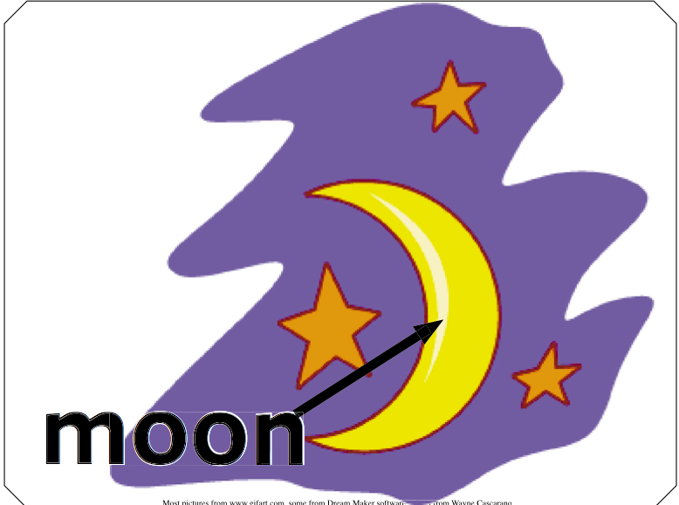
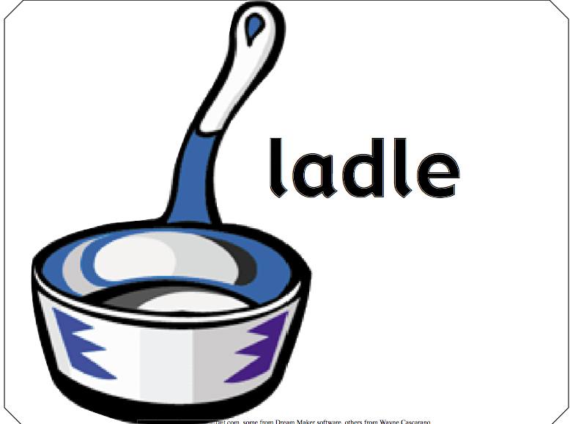
There was a man lived in the moon, in the moon, in the moon. There was a man lived in the moon. And his name was Aikendrum

And he played upon a ladle, a ladle, a ladle.
He played upon a ladle.
And his name was Aikendrum

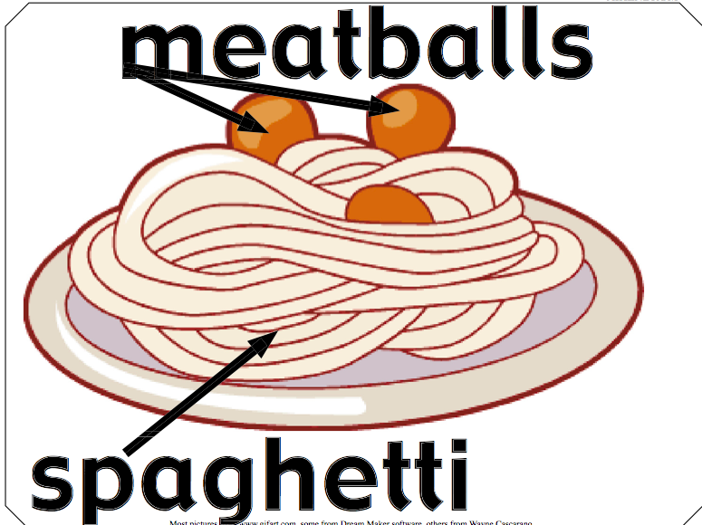
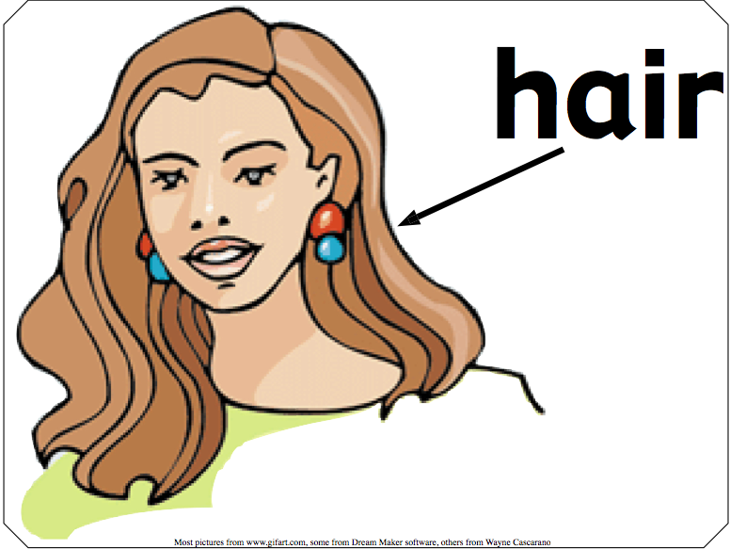
And his hair was made of spaghetti, spaghetti, spaghetti. His hair was made of spaghetti.
And his name was Aikendrum

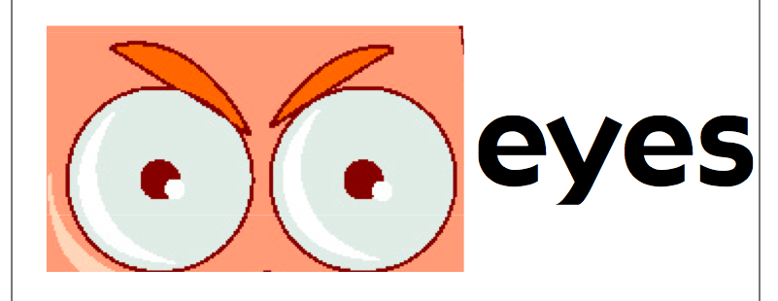
And his eyes were made of meatballs, meatballs, meatballs.
His eyes were made of meatballs.
And his name was Aikendrum.

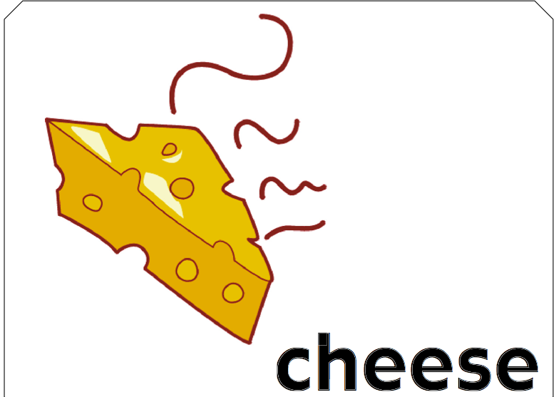
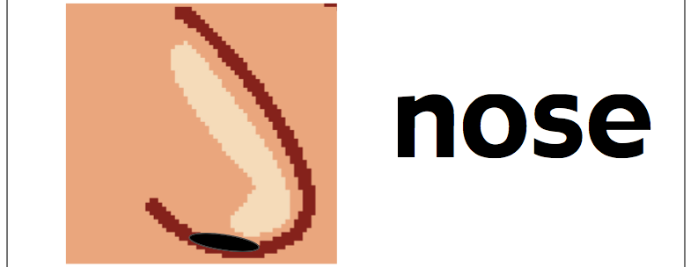
And he played upon a ladle, a ladle, a ladle.
He played upon a ladle.
And his name was Aikendrum

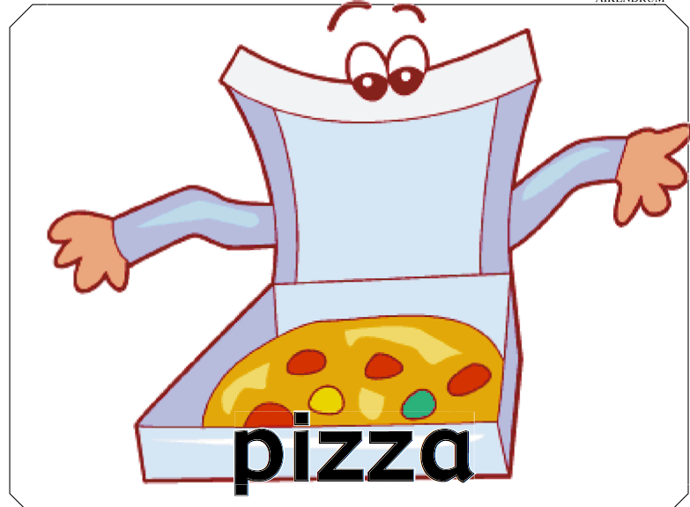
And his nose was made of cheese, cheese, cheese. His nose was made of cheese.
And his name was Aikendrum

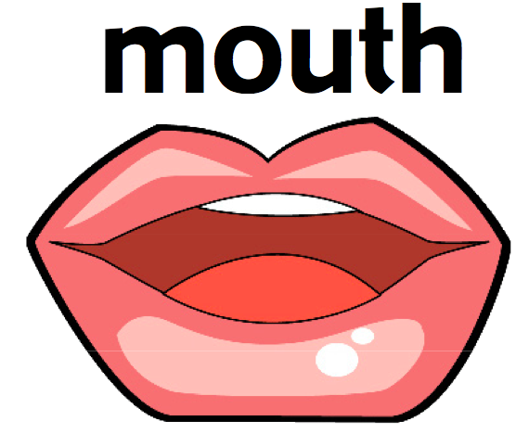
And his mouth was made of pizza, pizza, pizza. His mouth was made of pizza.
And his name was Aikendrum

And he played upon a ladle, a ladle, a ladle.
He played upon a ladle.
And his name was Aikendrum.

There was a man lived in the moon, in the moon, in the moon. There was a man lived in the moon. And his name was Aikendrum.

