Kate Pettersen - Tuesday Feb. 25, 2014 08:45 ET
Mark McMorris, slopestyle star, provided Canada's 1st medal in Sochi
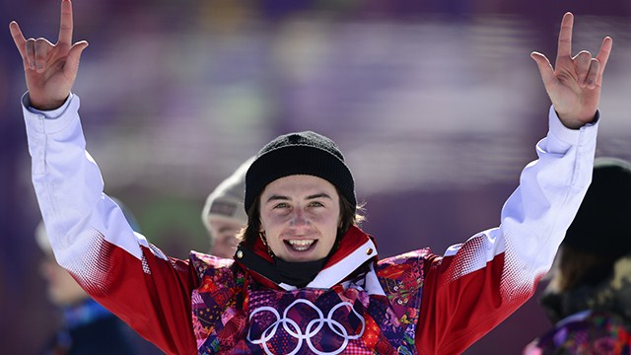
Canada's Mark Mcmorris celebrates his bronze medal at the end of the men's snowboard slopestyle final on Day 1 of the Winter Olympic Games in Sochi. (Javier Soriano/AFP/Getty Images)

The very first medal handed out in Sochi was in men's snowboard slopestyle, one of the new events, where competitors descend down the mountain on a course of rails and jumps, performing outrageously complicated stunts. There were new events for snowboarders in slopestyle and parallel slalom, both for men and women. Many had been on the X Games programme for years but the Olympics thrust the events on to a much bigger audience. "Heck yeah, it's the biggest stage in the world," said Jamie Anderson, who won the women's snowboard slopestyle. "X Games is the biggest event in action sports but the Olympics is the biggest in the whole world."

Mark McMorris of Regina won Canada’s first medal in Sochi capturing bronze in the inaugural men's snowboard slopestyle event on Day 1 of the Games despite competing with a broken rib. McMorris, considered slopestyles top medal contender, fell in his first run of the final round. He needed a strong second run to land on the podium, and the 20-year-old delivered with a score of 88.75.

What is new for the slopestyle discipline?

Who is Jamie Anderson?

What happened to McMorris on his first run?

Retieved from http://olympics.cbc.ca/news/article/mark-mcmorris-slopestyle-star-wins-canada-first-medal-sochi.html

