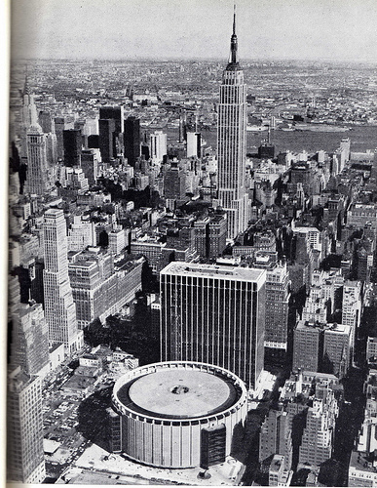

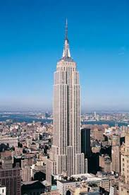

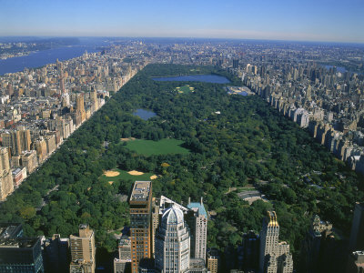

Madison Square Garden
Madison Square Garden is a multi-purpose indoor arena in New York City. It is like the Bell center in Montreal or Le Colisée in Quebec. You can watch there an NHL Rangers hockey game or an NBA Knick basketball game. Famous artists such as Lady Gaga, Justin Bibber or The Black Eyed Peas have performed at Madison Square Garden. Tourists always like to stop by the Madison Square Garden.

The Empire State Building
This is the tallest building in New York City. It was also the tallest building in the world until 1971. It has 102 floors and two observations decks. On the 86th floor, there is one, bigger, where you can have a wonderful view of New York City. There is another one, smaller, on the 102nd floor. The Empire State Building is a very popular attraction. Many tourists go there. You can also see the building in many movies. In the movie “King Kong”, a giant gorilla climbs the Empire State Building.
Central Park
Central Park is a very big park in the middle of Manhattan, in New York City. It is so big that you can find many things inside the park. You can find a zoo, a boathouse, a big lake and many small lakes. During summer, it is a good place to watch birds or have a picnic. During winter, there are two ice skating rinks and you can do cross-country skiing. The Metropolitan Museum of Art, a very popular museum, is also in Central Park.

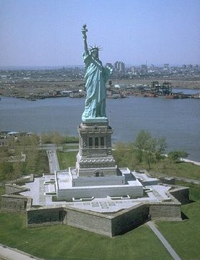

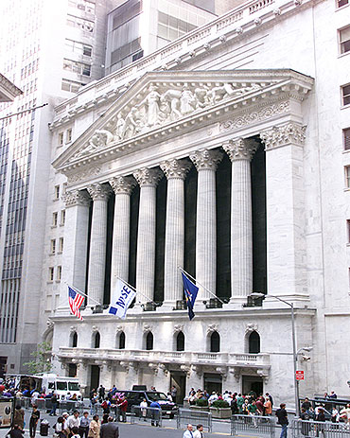

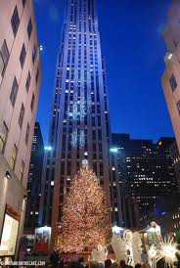

The Statue of Liberty
The Statue of Liberty is the most popular touristic attraction in New York City. The statue was a gift from France for the 100th anniversary of the United States of America in 1876. The statue itself is 46 metres high. Including the base, it is 93 meters high. The indoor stairs of the statue can take you up to the crown. You need to take the ferry if you want to visit the statue because it is on an island.

The New York Stock Exchange
It is also called Wall Street because the building is located at 11 Wall Street in Lower Manhattan. It is the most important building in the world for financial trade. It is very prestigious. The Wall Street Crash of 1929 happened in this building. It was the most devastating economic crisis in the history of the USA. Tourists enjoy stopping by this important building of New York City. Who knows? It might bright chance and prosperity!

Rockefeller Center
The Rockefeller Center is a popular building. Inside, there is a shopping center, an art center, many concert rooms and the NBC studios are also located there. The Radio City Music Hall, in the Rockefeller Center, is the most popular concert room in New York. During winter, there is a huge skating rink in front of the building and for Christmas a giant Christmas tree is put up between the skating rink and the building.

