Opposites Attract
Instructions
Associate each word in the left column to its opposite word in the right column.

Hot | ◆ | ◆ | Night
Tall | ◆ | ◆ | Difficult
Easy | ◆ | ◆ | Summer
Light | ◆ | ◆ | Closed
Water | ◆ | ◆ | Small
Left | ◆ | ◆ | Fire
Day | ◆ | ◆ | Hard
Soft | ◆ | ◆ | Dark
Start | ◆ | ◆ | Front
Expensive | ◆ | ◆ | Cheap
Back | ◆ | ◆ | Old
Winter | ◆ | ◆ | Up
Open | ◆ | ◆ | White
Black | ◆ | ◆ | Right
Yucky | ◆ | ◆ | Cold
Alive | ◆ | ◆ | Slow
Young | ◆ | ◆ | Yummy
Fast | ◆ | ◆ | Stop
Lasr | ◆ | ◆ | First
Down | ◆ | ◆ | Dead

Instructions
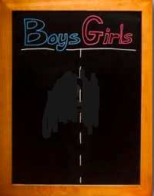
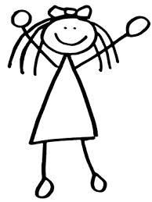
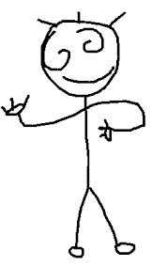
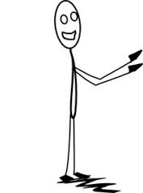
Study the opposite words. Your teacher will divide the class in two groups that will compete one against the other. The groups will form two lines. The teacher will say a word and then, the first student in each row will try to answer with the opposite of this word. The first student to answer will give a point to his or her team.
Tall

