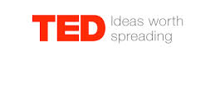

Patricia Kuhl: The Linguistic Genius of Babies

1. Answer these questions with complete sentences.

- What is the critical period?

- When does a child start losing the ability to learn a language?

- Before the age of one, what are babies doing when they listen to languages and sounds?

- Can babies learn a language from watching videos?

- Why is Mrs Kuhl investigating babies’ brain? What are the implications for adult language learners?

2. What information surprised you the most?

3. Choose two words that sum up the talk well. Be ready to explain your choice.

4. Below is a quote of Kuhl’ talk. Rephrase her sayings. Explain what she means by “citizens of the world.”
“Babies all over the worlds are what I like to describe as ‘citizens of the world.’ They can discriminate all the sounds of all the languages, no matter what country we’re testing and what language we’re using.”

5. Considering the information you just learned, let’s do a quick debate about the new intensive English program in grade 6. On a separate sheet, prepare 4 arguments, 2 for and 2 against.

