**Where are you?**

-Useful Prepositions-

**1. Write the prepositions in the appropriate square.**

**In**

**On**

**Under**

**On the left of**

**On the right of**

**Over**

**Next to**

**In the middle**

**On top of**

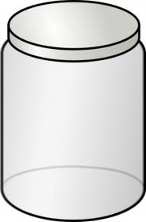

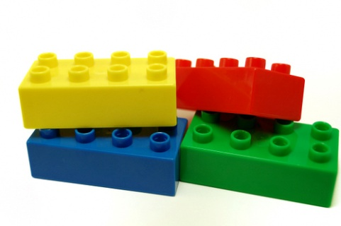

By Geneviève Hardy

1. Start with a ________(color) ______(size) brick.
2. Take a ________(color) ______(size) brick.
3. Put it _______(preposition) the _______(color) ______(size) brick.
4. Take a ________(color) ______(size) brick.
5. Put it _______(preposition) the _______(color) ______(size) brick.
6. Take a ________(color) ______(size) brick.
7. Put it _______(preposition) the _______(color) ______(size) brick.