NAME____________________________
GROUP ___________________________
DATE___________________________

ELEMENTARY CYCLE TWO
END OF THE YEAR EXAM
STUDENT BOOKLET

BY
GENEVIÈVE HARDY

DO YOU KNOW THE SMURFS?
These tiny blue people three apples high live hidden deep in a forest. They live all together, as a big and happy family. They spend their day singing and most of them are hard workers. The Smurfs live in mushroom shaped house of various colors. Outside, the houses all look the same, but inside, they really show the smurfs different personnalities.
http://www.schlumpf.com/en/meet-the-smurfs/village
http://www.englishbaby.com/lessons/5730/movies/the_smurfs

WARM UP!
HOW DO YOU DESCRIBE SOMETHING OR SOMEONE? CONJUGATE THE VERBS “TO BE” AND “TO LIKE” IN SIMPLE PRESENT.
TO BE | TO LIKE
I ____________________  You ___________________  He / She / It ________________  We ___________________  You ___________________  They __________________ | I ____________________  You ___________________  He / She / It ________________  We ___________________  You ___________________  They __________________

WORD BOX | TO WEAR: to have clothes or other items on your body.  TO DISLIKE: when you do not like.  TO LIVE: the place where your home is.  __________________________________________________  __________________________________________________  __________________________________________________  __________________________________________________

STEP A ( C2: __ / 17)
LEARN MORE ABOUT THESE SMALL CREATURES BY READİNG THE SHORT TEXTS BELOW. WRİTE THE SMURFS’ NAMES ON THE PİCTURES.
1. Papa Smurf is the leader of the Smurfs. The Smurfs wear blue, but he wears red. He has a white beard. He performs magic tricks.
2. Brainy Smurf is Papa Smurf’s assistant. He wears glasses. He thinks that he is intelligent. He always reads and writes books. He is very talkative and the other Smurfs usually do not like it.
3. Handy Smurf wears a hat and carries a pencil above his ear. He can fix everything.
4. Vanity Smurf thinks he is the most beautiful of the Smurfs. He always carries a mirror. There is a flower on his head.
5. Smurfette is the only girl in the village. She has long wavy blond hair. She is pretty.
6. Hefty Smurf is very strong. He can lift and carry everything. He has a heart tattoo on his shoulder. His best friend is Handy.
7. Jokey Smurf likes making jokes. He is always cheerful and happy. He enjoys playing tricks. He always carries a box and it usually explodes.
8. Grouchy Smurf is always angry. He always says ‘I hate’. He hates everything. He never smiles.
9. Dreamy Smurf always dreams. He is imaginative
10. Clumsy Smurf always makes mistakes. His hat is big so he cannot see his way and he always falls down.
11. Greedy Smurf is a cook. He makes good food and likes to eat. He wears a cook hat and a white apron. He is always hungry.
12. Sloppy Smurf is very dirty. He does not smell good. He likes garbage and rotten fruits.
13. Harmony Smurf is a musician. He plays trumpet. He always sings, but the other Smurfs want him to stop. He is very creative.
14. Painter Smurf is an artist. He likes to paint. He likes colours. He often wears a red jacket and a black tie. He carries a colour palette.
15. Poet Smurf is the poet of the village. He is very sensitive. He always writes poems and carries a pencil and paper in his hand.
16. Gargamel is the enemy of the Smurfs. He is a wicked sorcerer. He wants to catch and eat them. He is evil. He wears a black costume. He has a few teeth and a little hair.
17. Azrael is Gargamel’s pet cat. Gargamel doesn’t treat him well. He hunts the Smurfs in the forest.

 | 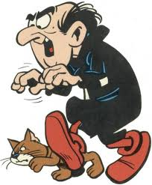 | 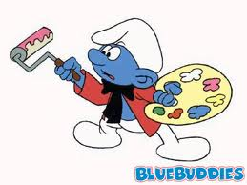 | 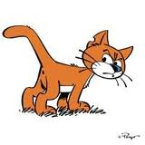
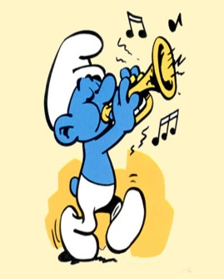 | 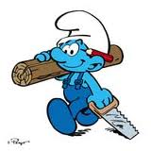
 |  | 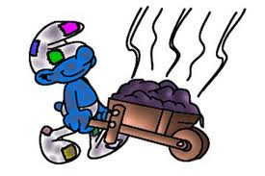

STEP B ( C2: __ / 7)
ANSWER THE QUESTIONS
Who is Papa Smurf’s assistant? (1)
___________________________________________________________
What is Greedy’s job? What does he do? (2)
___________________________________________________________
___________________________________________________________
Is Handy an artist? Why? (2)
___________________________________________________________
Who is the magician in the village? (1)
_____________________________
What colour is Painter’s jacket? (1)
______________________________

STEP B ( C2: __ / 7)
CIRCLE THE GOOD ANSWER.
Does Grouchy like playing tricks? | YES | NO
Where do the Smurfs live? | In a village | In a village
Who is the leader of the smurf? | Gargamel | Papa Smurf
Is Gargamel a good character? | YES | NO
Is Vanity a girl? | YES | NO
Who is strong? | Hefty | Brainy
Who is creative? | Grouchy | Painter

Grade 4 students.
STEP C ( C3 : __ / 4)
Describe a Smurf house in two sentences. Use the verb to be.
It is ________________________________________________________________
________________________________________________________________________________________________________________________________________
STEP D ( C1: __ / 10)
FILL IN THE BLANKS WITH THE NAMES OF PEOPLE THESE SMURFS MAKE YOU THINK OF.
CLUMSY :…………………………………………………………..
EVIL:………………………………………………………………
HEFTY: ………………………………………………………….
GROUCHY:……………………………………………….
GREEDY:……………………………………………………….
BRAINY: …………………………………………………..
POET:………………………………………………………
SLOPPY:……………………………………………………..
PAINTER:…………………………………………………….
SMURFETTE:……………………………………………..

STEP E ( C1: __ / 10)
NOW, IN TEAMS, DISCUSS YOUR CHOICES. EXPLAIN WHY THE DIFFERENT SMURFS MAKE YOU THINK OF THESE PEOPLE.
Use this language to help you.
Who makes you think of Papa Smurf?
My dad makes me think of Papa Smurf?

Can you tell us why?
Because ...

I agree!
Can you speak louder?
It is funny!
Can you repeat please?

I don’t understand.
Good idea!

STEP F ( C3: __ / 10)
NOW THAT YOU ARE A SMURF SPECIALIST, IMAGINE A NEW SMURF.
Your text must include:
- What he wears.
- How he is.
- What he likes.
- One extra sentence, or more.
- A drawing of your Smurf.
This is Space Smurf.
He wears an astronaut suit and big boots.
He is funny, but serious.
He likes science and astronomy.
*** He knows everything about the solar system and the eight planets.

ROUGH DRAFT
________________________________________________________________________________________________________________________________________
________________________________________________________________________________________________________________________________________
________________________________________________________________________________________________________________________________________________________________________________________________________________________________________________________________________________

FINAL DRAFT
____________________________________________
____________________________________________
____________________________________________
____________________________________________
____________________________________________
____________________________________________
____________________________________________
____________________________________________
____________________________________________
____________________________________________
____________________________________________
____________________________________________
____________________________________________
________________________________________________________________________________________________________________________________________________________________________________

STEP E ( C1: __ / 10)
WHAT ABOUT YOUR SMURF?
NOW, ROUND ROBIN STYLE, PRESENT YOU SMURF TO YOU PEERS.

