Created by Valérie Côté, Carolyn Croteau, Geneviève Hardy and Frédérick Noiseux. 2011.

[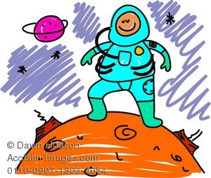](javascript:calc_price('RF','0110-0907-1803-4054%7C6253%7C5294%7CCommercial%7C%7C%7C1%7C1'))

Figure 1 Hudson, D. Image retrieved from http://www.acclaimimages.com/\_gallery/\_pages/0110-0907-1803-4054.html

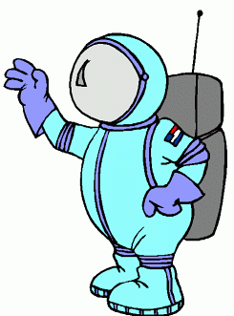

* **Space Geography**
* **Spacecrafts**
* **Space History**
* **Living in the Space**

**Functional Language**

What do you think?

Can you repeat please?

I do not understand...

Do you agree?

I agree. I DISAGREE.

Excuse me.

If you don’t mind...

Can you help me?

What about you?

I know that... I think that...

I do not know. Do you know?

**Strategies**

Gestures RECAST Rephrase SUBSTITUTION

STALL FOR TIME

The space shuttle is NASA's space transportation system, designed to carry astronauts and cargo to and from Earth orbit. The first space shuttle flight took place in 1981. The space shuttle fleet is scheduled to retire in 2011. When the shuttle program ends, the space shuttle will have been launched on more than 130 missions.

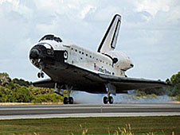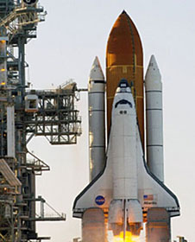**What Can the Space Shuttle Do?**  
The space shuttle normally takes as many as seven astronauts to and from space. During its history, the space shuttle has been used for many different types of missions. First, it has been used to launch satellites and serve as an orbiting science laboratory. Second, its crews have repaired and improved other spacecraft, such as the Hubble Space Telescope. Finally, the shuttle has been used for military missions. Today, the space shuttle is mostly used to work on the International Space Station.   
  
**What Are the Parts of the Space Shuttle?**  
The space shuttle has three main parts. The first part is the orbiter. The orbiter is the large, white space plane where the crew lives and works. It is the only part of the shuttle that goes into orbit. The orbiter also has a payload bay for carrying cargo into orbit. The second part of the shuttle is the external tank. This is the large orange fuel tank that attaches to the bottom of the orbiter for launch. The third part is actually two pieces. A pair of white solid rocket boosters provides most of the thrust for the first two minutes of a shuttle launch. The solid rocket boosters are long and thin.   
  
**How Does the Space Shuttle Launch and Land?**  
The space shuttle takes off like a rocket. The solid rocket boosters and the main engines on the orbiter provide the thrust, or push, for launch. The solid rocket boosters burn for about two minutes. Then they are dropped from the shuttle and fall into the ocean. Special boats bring them back so they can be used again. The shuttle’s main engines fire for another six minutes. The external tank is dropped and burns up in the Earth’s atmosphere. At this point, the shuttle and its crew are in orbit. The orbiter lands like a glider. While in orbit, it fires its engines to slow down. After re-entering Earth’s atmosphere, it glides in for a landing on a runway. When the orbiter touches down on the runway, a parachute is used to help slow it down.

**How Many Orbiters Are There?**  
Today, there are three orbiters that fly into space. They are Discovery, Atlantis and Endeavour. Since the shuttle began flying in 1981, two orbiters, Columbia and Challenger, have been lost due to accidents. One other orbiter, Enterprise, never flew into space. It was built to test how the orbiters would work and now is on display at the National Air and Space Museum near Washington, D.C.

http://www.nasa.gov/audience/forstudents/5-8/features/what-is-the-space-shuttle-58.html



**What Is the Space Shuttle?**

|  |
| --- |
| Read the following questions and answer them using the text.  Write complete sentences. |

1. When was the space shuttle first used?
2. When is the space shuttle fleet supposed to retire?

|  |
| --- |
|  |

1. How old will the space shuttle be when it retires? \_\_\_\_\_\_\_\_\_\_\_\_\_\_\_\_
2. Name three types of missions the space shuttle has been used for.

|  |  |  |
| --- | --- | --- |
| **1** | **2** | **3** |
|  |  |  |
|  |  |  |
|  |  |  |
|  |  |  |
|  |  |  |
|  |  |  |
|  |  |  |
|  |  |  |

1. Today, what is the shuttle most used for?

|  |
| --- |
|  |

1. Name and briefly describe the three parts of a shuttle.

|  |  |  |
| --- | --- | --- |
| **1** | **2** | **3** |
|  |  |  |
|  |  |  |
|  |  |  |
|  |  |  |
|  |  |  |
|  |  |  |
|  |  |  |
|  |  |  |

1. What are the solid rocket boosters used for?

|  |
| --- |
|  |

1. What does the shuttle use to slow down when landing on Earth?

|  |
| --- |
|  |

1. What two orbiters have been lost due to accidents?

|  |
| --- |
|  |

10.

a) What was the Enterprise orbiter built for?

|  |
| --- |
|  |

b) Where do you have to go to see it?

|  |
| --- |
|  |

1. Sum up one thing you have learned through reading this text.

|  |
| --- |
|  |
|  |
|  |

1. What would be another good question about this text that your teacher could have asked to the class?

|  |
| --- |
|  |

**You Would Be a Good Astronaut if …**

Have you ever wondered if you have what it takes to become a NASA Astronaut?

There are several jobs available for astronauts who want to go in space. The main jobs available are the Commander, the Pilot and the Mission Specialist. The Commander is like the chief of the mission. He has onboard responsibilities for the vehicle, the crew, the mission success and the safety of the flight. The Pilot is the assistant of the commander in controlling and operating the vehicle. He **can** also assist the Mission Specialist. The Mission Specialists are the ones who perform the extravehicular activities and space walks. They also **have to** operate the remote manipulator system and are responsible of the specific experiments onboard.

To apply for one of these jobs you **must**:

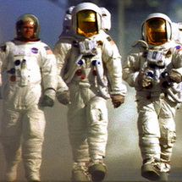

* have a bachelor’s degree in engineering, biological science, physical science or mathematics.
* have at least 1000 hours of pilot-in-command time in jet aircraft to become a pilot.
* be in good shape in order to pass the NASA physical exam.
* have a very good vision.
* not have high blood pressure.
* be between 62 and 75 inches high (1,58m – 1,91m) for Commanders or Pilots or between 58.5 and 76 inches high (1,49m – 1,93m) for Mission Specialists.

These advices might also help you to get the job:

* You **must** not have a criminal record.
* You **should** not have any psychological problems.
* You **will** need to have a clean appearance.
* It **may** be a good idea not to be claustrophobic.
* An astronaut **can** usually speak many languages.
* You **must** like to travel and meet several cultures.

So, do you think you would like it?

|  |
| --- |
| **Did you know?** The term *astronaut* refers to the space sailors who are members of the NASA space program. Besides, the term *cosmonaut* refers to the space sailors of the Russian space program and the term *taikonaut* refers to the ones of the Chinese space program. |

Inspired from : [http://www.nasa.gov/audience/forstudents/postsecondary/features/F\_Astronaut\_Requirements.html](http://www.nasa.gov/audience/forstudents/postsecondary/features/F_Astronaut_Requirements.html" \t "_blank)

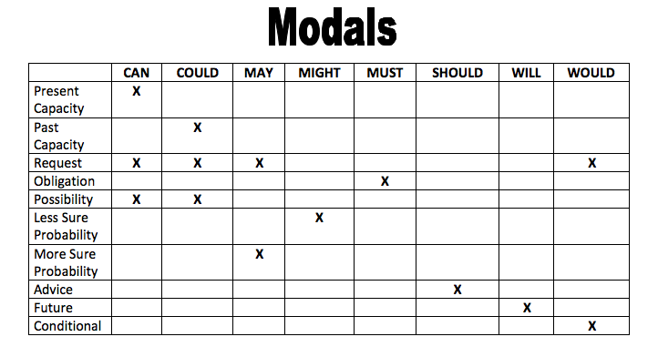Inspired from Matveyenko, N. & Charland, G. (1994). *Easy Essential Grammar.* Victoriaville, QC ; Les Éditions Shakespeare.

**Examples**

I can play piano

You should wear a tuque.

They will go to Cuba next month.

It is now you turn to take note of some examples.

|  |  |  |
| --- | --- | --- |
|  |  |  |
|  |  |  |
|  |  |  |
|  |  |  |



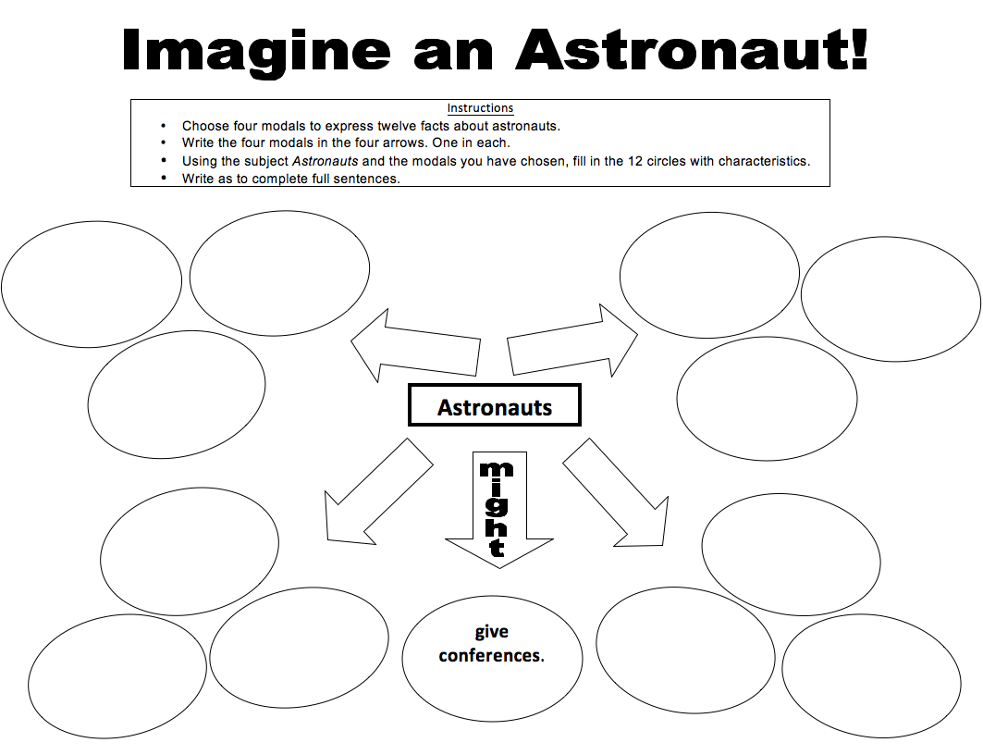

|  |  |
| --- | --- |
| **KEY KNOWLEDGE** | |
| SHOULD → ADVICE | MUST → OBLIGATION |
| CAN → PRESENT CAPACITY | COULD → PAST CAPACITY / POSSIBILITY |
| MIGHT → (-) PROBABILITY | MAY → (+) PROBABILITY |
| WILL → FUTURE | WOULD → CONDITIONAL / REQUEST |

**Fill in the blanks with the appropriate modal. Use the Key Knowledge box to help you.**

1. Mary \_\_\_\_\_\_\_\_\_\_\_\_ win the lottery this year.
2. If I had enough money, I \_\_\_\_\_\_\_\_\_\_\_\_ love to buy a new car.
3. Car drivers’ \_\_\_\_\_\_\_\_\_\_\_\_ respect the laws.
4. Next year, I \_\_\_\_\_\_\_\_\_\_\_\_ get a new IPod for Christmas.
5. Julien \_\_\_\_\_\_\_\_\_\_\_\_ go to the party tonight. He has not made up his mind yet.
6. When she was young, Anne \_\_\_\_\_\_\_\_\_\_\_\_ not ride a bicycle. Now she can.
7. You \_\_\_\_\_\_\_\_\_\_\_\_ listen to your mom and do your homework before supper.
8. I \_\_\_\_\_\_\_\_\_\_\_\_ cook good muffins without looking at a recipe.
9. Véronique \_\_\_\_\_\_\_\_\_\_\_\_ have a good mark if she would study harder.
10. My family and I \_\_\_\_\_\_\_\_\_\_\_\_ like to invite you for diner next Sunday.
11. Do you think I \_\_\_\_\_\_\_\_\_\_\_\_ do this exercise correctly?
12. \_\_\_\_\_\_\_\_\_\_\_\_ you be my partner for this game?
13. Young children \_\_\_\_\_\_\_\_\_\_\_\_ not swim in a pool without an adult looking at them; it is too dangerous.
14. Young children \_\_\_\_\_\_\_\_\_\_\_\_ not go to bed after 9 PM.
15. Next class, I \_\_\_\_\_\_\_\_\_\_\_\_ propose an idea to my teammates.
16. One day, this little boy humming \_\_\_\_\_\_\_\_\_\_\_\_ become famous.
17. - \_\_\_\_\_\_\_\_\_\_\_\_ I raise this heavy box?

* No. You would hurt yourself because you are not strong enough.



Individually, prepare to answer these interview questions. You can imagine whatever characteristics that could help you get the job. Create your own character, be creative!

Answer with complete sentences.

YOUR CHARACTER’S NAME: \_\_\_\_\_\_\_\_\_\_\_\_\_\_\_\_\_\_\_\_\_\_\_\_\_\_

1. What and where did you study? What is your degree?

|  |
| --- |
|  |
|  |

1. Are you in good shape? What will you do to improve your physical condition?

|  |
| --- |
|  |
|  |

1. Do you have any health problems? If so, which ones?

|  |
| --- |
|  |
|  |

1. Describe yourself physically. (Height, weight, hair color, age, gender, …)

|  |
| --- |
|  |
|  |

1. Do you have any psychological problems?

|  |
| --- |
|  |
|  |

1. Have you ever travelled to another country? Do you have any interesting experiences to share?

|  |
| --- |
|  |
|  |

1. What language(s) do you speak? Would you be interested in learning other languages?

|  |
| --- |
|  |
|  |

1. Why do you want to be an astronaut? Give at least two good reasons.

|  |
| --- |
|  |
|  |

Take notes of the candidates’ names.

Also, write down key information about their performance.

You job is to ask the same question to the different candidates that will sit at your desk.

**Question: \_\_\_\_\_\_\_\_\_\_\_\_\_\_\_\_\_\_\_\_\_\_\_\_\_\_\_\_\_\_\_\_\_\_\_\_\_\_\_\_\_\_\_\_\_\_\_\_\_\_\_\_\_\_\_\_\_\_\_**

Candidate 1. Name: \_\_\_\_\_\_\_\_\_\_\_\_\_\_\_\_\_\_\_\_\_\_\_\_\_\_\_\_\_\_\_\_\_\_\_\_\_\_\_\_\_

\_\_\_\_\_\_\_\_\_\_\_\_\_\_\_\_\_\_\_\_\_\_\_\_\_\_\_\_\_\_\_\_\_\_\_\_\_\_\_\_\_\_\_\_\_\_\_\_\_\_\_\_\_\_\_\_\_\_\_\_\_\_\_\_\_\_\_\_\_\_\_\_\_\_\_\_\_\_\_\_\_\_\_\_\_\_\_\_\_\_\_\_\_\_\_\_\_\_\_\_\_\_\_\_\_\_\_\_\_\_\_\_\_\_\_\_\_\_\_\_\_\_\_\_\_\_\_\_\_\_\_\_\_\_\_\_\_\_\_\_\_\_\_\_\_\_\_\_\_\_\_\_\_\_\_\_\_\_\_\_\_\_\_\_\_\_\_\_\_\_\_\_\_\_\_\_\_\_\_\_\_\_\_\_\_\_\_\_\_\_

Candidate 2. Name: \_\_\_\_\_\_\_\_\_\_\_\_\_\_\_\_\_\_\_\_\_\_\_\_\_\_\_\_\_\_\_\_\_\_\_\_\_\_\_\_\_

\_\_\_\_\_\_\_\_\_\_\_\_\_\_\_\_\_\_\_\_\_\_\_\_\_\_\_\_\_\_\_\_\_\_\_\_\_\_\_\_\_\_\_\_\_\_\_\_\_\_\_\_\_\_\_\_\_\_\_\_\_\_\_\_\_\_\_\_\_\_\_\_\_\_\_\_\_\_\_\_\_\_\_\_\_\_\_\_\_\_\_\_\_\_\_\_\_\_\_\_\_\_\_\_\_\_\_\_\_\_\_\_\_\_\_\_\_\_\_\_\_\_\_\_\_\_\_\_\_\_\_\_\_\_\_\_\_\_\_\_\_\_\_\_\_\_\_\_\_\_\_\_\_\_\_\_\_\_\_\_\_\_\_\_\_\_\_\_\_\_\_\_\_\_\_\_\_\_\_\_\_\_\_\_\_\_\_\_\_\_

Candidate 3. Name: \_\_\_\_\_\_\_\_\_\_\_\_\_\_\_\_\_\_\_\_\_\_\_\_\_\_\_\_\_\_\_\_\_\_\_\_\_\_\_\_\_

\_\_\_\_\_\_\_\_\_\_\_\_\_\_\_\_\_\_\_\_\_\_\_\_\_\_\_\_\_\_\_\_\_\_\_\_\_\_\_\_\_\_\_\_\_\_\_\_\_\_\_\_\_\_\_\_\_\_\_\_\_\_\_\_\_\_\_\_\_\_\_\_\_\_\_\_\_\_\_\_\_\_\_\_\_\_\_\_\_\_\_\_\_\_\_\_\_\_\_\_\_\_\_\_\_\_\_\_\_\_\_\_\_\_\_\_\_\_\_\_\_\_\_\_\_\_\_\_\_\_\_\_\_\_\_\_\_\_\_\_\_\_\_\_\_\_\_\_\_\_\_\_\_\_\_\_\_\_\_\_\_\_\_\_\_\_\_\_\_\_\_\_\_\_\_\_\_\_\_\_\_\_\_\_\_\_\_\_\_\_

Candidate 4. Name: \_\_\_\_\_\_\_\_\_\_\_\_\_\_\_\_\_\_\_\_\_\_\_\_\_\_\_\_\_\_\_\_\_\_\_\_\_\_\_\_\_

\_\_\_\_\_\_\_\_\_\_\_\_\_\_\_\_\_\_\_\_\_\_\_\_\_\_\_\_\_\_\_\_\_\_\_\_\_\_\_\_\_\_\_\_\_\_\_\_\_\_\_\_\_\_\_\_\_\_\_\_\_\_\_\_\_\_\_\_\_\_\_\_\_\_\_\_\_\_\_\_\_\_\_\_\_\_\_\_\_\_\_\_\_\_\_\_\_\_\_\_\_\_\_\_\_\_\_\_\_\_\_\_\_\_\_\_\_\_\_\_\_\_\_\_\_\_\_\_\_\_\_\_\_\_\_\_\_\_\_\_\_\_\_\_\_\_\_\_\_\_\_\_\_\_\_\_\_\_\_\_\_\_\_\_\_\_\_\_\_\_\_\_\_\_\_\_\_\_\_\_\_\_\_\_\_\_\_\_\_\_

Candidate 5. Name: \_\_\_\_\_\_\_\_\_\_\_\_\_\_\_\_\_\_\_\_\_\_\_\_\_\_\_\_\_\_\_\_\_\_\_\_\_\_\_\_\_

\_\_\_\_\_\_\_\_\_\_\_\_\_\_\_\_\_\_\_\_\_\_\_\_\_\_\_\_\_\_\_\_\_\_\_\_\_\_\_\_\_\_\_\_\_\_\_\_\_\_\_\_\_\_\_\_\_\_\_\_\_\_\_\_\_\_\_\_\_\_\_\_\_\_\_\_\_\_\_\_\_\_\_\_\_\_\_\_\_\_\_\_\_\_\_\_\_\_\_\_\_\_\_\_\_\_\_\_\_\_\_\_\_\_\_\_\_\_\_\_\_\_\_\_\_\_\_\_\_\_\_\_\_\_\_\_\_\_\_\_\_\_\_\_\_\_\_\_\_\_\_\_\_\_\_\_\_\_\_\_\_\_\_\_\_\_\_\_\_\_\_\_\_\_\_\_\_\_\_\_\_\_\_\_\_\_\_\_\_\_

Candidate 6. Name: \_\_\_\_\_\_\_\_\_\_\_\_\_\_\_\_\_\_\_\_\_\_\_\_\_\_\_\_\_\_\_\_\_\_\_\_\_\_\_\_\_

\_\_\_\_\_\_\_\_\_\_\_\_\_\_\_\_\_\_\_\_\_\_\_\_\_\_\_\_\_\_\_\_\_\_\_\_\_\_\_\_\_\_\_\_\_\_\_\_\_\_\_\_\_\_\_\_\_\_\_\_\_\_\_\_\_\_\_\_\_\_\_\_\_\_\_\_\_\_\_\_\_\_\_\_\_\_\_\_\_\_\_\_\_\_\_\_\_\_\_\_\_\_\_\_\_\_\_\_\_\_\_\_\_\_\_\_\_\_\_\_\_\_\_\_\_\_\_\_\_\_\_\_\_\_\_\_\_\_\_\_\_\_\_\_\_\_\_\_\_\_\_\_\_\_\_\_\_\_\_\_\_\_\_\_\_\_\_\_\_\_\_\_\_\_\_\_\_\_\_\_\_\_\_\_\_\_\_\_\_\_

Candidate 7. Name: \_\_\_\_\_\_\_\_\_\_\_\_\_\_\_\_\_\_\_\_\_\_\_\_\_\_\_\_\_\_\_\_\_\_\_\_\_\_\_\_\_

\_\_\_\_\_\_\_\_\_\_\_\_\_\_\_\_\_\_\_\_\_\_\_\_\_\_\_\_\_\_\_\_\_\_\_\_\_\_\_\_\_\_\_\_\_\_\_\_\_\_\_\_\_\_\_\_\_\_\_\_\_\_\_\_\_\_\_\_\_\_\_\_\_\_\_\_\_\_\_\_\_\_\_\_\_\_\_\_\_\_\_\_\_\_\_\_\_\_\_\_\_\_\_\_\_\_\_\_\_\_\_\_\_\_\_\_\_\_\_\_\_\_\_\_\_\_\_\_\_\_\_\_\_\_\_\_\_\_\_\_\_\_\_\_\_\_\_\_\_\_\_\_\_\_\_\_\_\_\_\_\_\_\_\_\_\_\_\_\_\_\_\_\_\_\_\_\_\_\_\_\_\_\_\_\_\_\_\_\_\_

Candidate 8. Name: \_\_\_\_\_\_\_\_\_\_\_\_\_\_\_\_\_\_\_\_\_\_\_\_\_\_\_\_\_\_\_\_\_\_\_\_\_\_\_\_\_

\_\_\_\_\_\_\_\_\_\_\_\_\_\_\_\_\_\_\_\_\_\_\_\_\_\_\_\_\_\_\_\_\_\_\_\_\_\_\_\_\_\_\_\_\_\_\_\_\_\_\_\_\_\_\_\_\_\_\_\_\_\_\_\_\_\_\_\_\_\_\_\_\_\_\_\_\_\_\_\_\_\_\_\_\_\_\_\_\_\_\_\_\_\_\_\_\_\_\_\_\_\_\_\_\_\_\_\_\_\_\_\_\_\_\_\_\_\_\_\_\_\_\_\_\_\_\_\_\_\_\_\_\_\_\_\_\_\_\_\_\_\_\_\_\_\_\_\_\_\_\_\_\_\_\_\_\_\_\_\_\_\_\_\_\_\_\_\_\_\_\_\_\_\_\_\_\_\_\_\_\_\_\_\_\_\_\_\_\_\_\_\_\_\_\_\_

**What about Guy Laliberté?**

|  |
| --- |
| Answer the following questions. Use complete sentences. |

1. Besides his career, what does Guy Laliberté want to be?
2. Guy Laliberté is the first space tourist from his country. What country is it?
3. What is also part of the experience for Guy Laliberté?
4. According to Laliberté, what are the two things that give you reason to go forward?
5. What three skills did he have to work on?
6. What is his first priority?
7. Why isn’t Laliberté a stranger to big challenges?
8. When does Laliberté expect to be the most sensitive?

|  |  |
| --- | --- |
| **Would** you pay to go into space? | |
|  |
| Instructions   * 75 words * Introduction   + State your thesis statement (Yes or No) * 2 arguments with explanations (Why?) * Conclusion   + Restate your thesis statement. | |

\_\_\_\_\_\_\_\_\_\_\_\_\_\_\_\_\_\_\_\_\_\_\_\_\_\_\_\_\_\_\_\_\_\_\_\_\_\_\_\_\_\_\_\_\_\_\_\_\_\_\_\_\_\_\_\_\_\_\_\_\_\_\_\_\_\_\_\_\_\_\_\_\_\_\_\_\_\_\_\_\_\_\_\_\_\_\_\_\_\_\_\_\_\_\_\_\_\_\_\_\_\_\_\_\_\_\_\_\_\_\_\_\_\_\_\_\_\_\_\_\_\_\_\_\_\_\_\_\_\_\_\_\_\_\_\_\_\_\_\_\_\_\_\_\_\_\_\_\_\_\_\_\_\_\_\_\_\_\_\_\_\_\_\_\_\_\_\_\_\_\_\_\_\_\_\_\_\_\_\_\_\_\_\_\_\_\_\_\_\_\_\_\_\_\_\_\_\_\_\_\_\_\_\_\_\_\_\_\_\_\_\_\_\_\_\_\_\_\_\_\_\_\_\_\_\_\_\_\_\_\_\_\_\_\_\_\_\_\_\_\_\_\_\_\_\_\_\_\_\_\_\_\_\_\_\_\_\_\_\_\_\_\_\_\_\_\_\_\_\_\_\_\_\_\_\_\_\_\_\_\_\_\_\_\_\_\_\_\_\_\_\_\_\_\_\_\_\_\_\_\_\_\_\_\_\_\_\_\_\_\_\_\_\_\_\_\_\_\_\_\_\_\_\_\_\_\_\_\_\_\_\_\_\_\_\_\_\_\_\_\_\_\_\_\_\_\_\_\_\_\_\_\_\_\_\_\_\_\_\_\_\_\_\_\_\_\_\_\_\_\_\_\_\_\_\_\_\_\_\_\_\_\_\_\_\_\_\_\_\_\_\_\_\_\_\_\_\_\_\_\_\_\_\_\_\_\_\_\_\_\_\_\_\_\_\_\_\_\_\_\_\_\_\_\_\_\_\_\_\_\_\_\_\_\_\_\_\_\_\_\_\_\_\_\_\_\_\_\_\_\_\_\_\_\_\_\_\_\_\_\_\_\_\_\_\_\_\_\_\_\_\_\_\_\_\_\_\_\_\_\_\_\_\_\_\_\_\_\_\_\_\_\_\_\_\_\_\_\_\_\_\_\_\_\_\_\_\_\_\_\_\_\_\_\_\_\_\_\_\_\_\_\_\_\_\_\_\_\_\_\_\_\_\_\_\_\_\_\_\_\_\_\_\_\_\_\_\_\_\_\_\_\_\_\_\_\_\_\_\_\_\_\_\_\_\_\_\_\_\_\_\_\_\_\_\_\_\_\_\_\_\_\_\_\_\_\_\_\_\_\_\_\_\_\_\_\_\_\_\_\_\_\_\_\_\_\_\_\_\_\_\_\_\_\_\_\_\_\_\_\_\_\_\_\_\_\_\_\_\_\_\_\_\_\_\_\_\_\_\_\_\_\_\_\_\_\_\_\_\_\_\_\_\_\_\_\_\_\_\_\_\_\_\_\_\_\_\_\_\_\_\_\_\_\_\_\_\_\_\_\_\_\_\_\_\_\_\_\_\_\_\_\_\_\_\_\_\_\_\_\_\_\_\_\_\_\_\_\_\_\_\_\_\_\_\_\_\_\_\_\_\_\_\_\_\_\_\_\_\_\_\_\_\_\_\_\_\_\_\_\_\_\_\_\_\_\_\_\_\_\_\_\_\_\_\_\_\_\_\_\_\_\_\_\_\_\_\_\_\_\_\_\_\_\_\_\_\_\_\_\_\_\_\_\_\_\_\_\_\_\_\_\_\_\_\_\_\_\_\_\_\_\_\_\_\_\_\_\_\_\_\_\_\_\_\_\_\_\_\_\_\_\_\_\_\_\_\_\_\_\_\_\_\_\_\_\_\_\_\_\_\_\_\_\_\_\_\_\_\_\_\_\_\_\_\_\_\_\_\_\_\_\_\_\_\_\_\_\_\_\_\_\_\_\_\_\_\_\_\_\_\_\_\_\_\_\_\_\_\_\_\_\_\_\_\_\_\_\_\_\_\_\_\_\_\_\_\_\_\_\_\_\_\_\_\_\_\_\_\_\_\_\_\_\_\_\_\_\_\_\_\_\_\_\_\_\_\_\_\_\_\_\_\_\_\_\_\_\_\_\_\_\_\_\_\_\_\_\_\_\_\_\_\_\_\_\_\_\_\_\_\_\_\_\_\_\_\_\_\_\_\_\_\_\_\_\_\_\_\_\_\_\_\_\_\_\_\_\_\_\_\_\_\_\_\_\_\_\_\_\_\_\_\_\_\_\_\_\_\_\_\_\_\_\_\_\_\_\_\_\_\_\_\_\_\_\_\_\_\_\_\_\_\_\_\_\_\_\_\_\_\_\_\_\_\_\_\_\_\_\_\_\_\_\_\_\_\_\_\_\_\_\_\_\_\_\_\_\_\_\_\_\_\_\_\_\_\_\_\_\_\_\_\_\_\_\_\_\_\_\_\_\_\_\_\_\_\_\_\_\_\_\_\_\_\_\_\_\_\_\_\_\_\_\_\_\_\_\_\_\_\_\_\_\_\_\_\_\_\_\_\_\_\_\_\_\_\_\_\_\_\_\_\_\_\_\_\_\_\_\_\_\_\_\_\_\_\_\_\_\_\_\_\_\_\_\_\_\_\_\_\_\_\_\_\_\_\_\_\_\_\_\_\_\_\_\_\_\_\_\_\_\_\_\_\_\_\_\_\_\_\_\_\_\_\_\_\_\_\_\_\_\_\_\_\_\_\_\_\_\_\_\_\_\_\_\_\_\_\_\_\_\_\_\_\_\_\_\_\_\_\_\_\_\_\_\_\_\_\_\_\_\_\_\_\_\_\_\_\_\_\_\_\_\_\_\_\_\_\_\_\_\_\_\_\_\_\_\_\_\_\_\_\_\_\_\_\_\_\_\_\_\_\_\_\_\_\_\_\_\_\_\_\_\_\_\_\_\_\_\_\_\_\_\_\_\_\_\_\_\_\_\_\_\_\_\_\_\_\_\_\_\_\_\_\_\_\_\_\_\_\_\_\_\_\_\_\_\_\_\_\_\_\_\_\_\_\_\_\_\_\_\_\_\_\_\_\_\_\_\_\_\_\_\_\_\_\_\_\_\_\_\_\_\_\_\_\_\_\_\_\_\_\_\_\_\_\_\_\_\_\_\_\_\_\_\_\_\_\_\_\_\_\_\_\_\_\_\_\_\_\_\_\_\_\_\_\_\_\_\_\_\_\_\_\_\_\_\_\_\_\_\_\_\_\_\_\_\_\_\_\_\_\_\_\_\_\_\_\_\_\_\_\_\_\_\_\_\_\_\_\_\_\_\_\_\_\_\_\_\_\_\_\_\_\_\_\_\_\_\_\_\_\_\_\_\_\_\_\_\_\_\_\_\_\_\_\_\_\_\_\_\_\_\_\_\_\_\_\_\_\_\_\_\_\_\_\_\_\_\_\_\_\_\_\_\_\_\_\_\_\_\_\_\_\_\_\_\_\_\_\_\_\_\_\_\_\_\_\_\_\_\_\_\_\_\_\_\_\_\_\_\_\_\_\_\_\_\_\_\_\_\_\_\_\_\_\_\_\_\_\_\_\_\_\_\_\_\_\_\_\_\_\_\_\_\_\_\_\_\_\_\_\_\_\_\_\_\_\_\_\_\_\_\_\_\_\_\_\_\_\_\_\_\_\_\_\_\_\_\_\_\_\_\_\_\_\_\_\_\_\_\_\_\_\_\_\_\_\_\_\_\_\_\_\_\_\_\_\_\_\_\_\_\_\_\_\_\_\_\_\_\_\_\_\_\_\_\_\_\_\_\_\_\_\_\_\_\_\_\_\_\_\_\_\_\_\_\_\_\_\_\_\_\_\_\_\_\_\_\_\_\_\_\_\_\_\_\_\_\_\_\_\_\_\_\_\_\_\_\_\_\_\_\_\_\_\_\_\_\_\_\_\_\_\_\_\_\_\_\_\_\_\_\_\_\_\_\_\_\_\_\_\_\_\_\_\_\_\_\_\_\_\_\_\_\_\_\_\_\_\_\_\_\_\_\_\_\_\_\_\_\_\_\_\_\_\_\_\_\_\_\_\_\_\_\_\_\_\_\_\_\_\_\_\_\_\_\_\_\_\_\_\_\_\_\_\_\_\_\_\_\_\_\_\_\_\_\_\_\_\_\_\_\_\_\_\_\_\_\_\_\_\_\_\_\_\_\_\_\_\_\_\_\_\_\_\_\_\_\_\_\_\_\_\_\_\_\_\_\_\_\_\_\_\_\_\_\_\_\_\_\_\_\_\_\_\_\_\_\_\_\_\_\_\_\_\_\_\_\_\_\_\_\_\_\_\_\_\_\_\_\_\_\_\_\_\_\_\_\_\_\_\_\_\_\_\_\_\_\_\_\_\_\_\_\_\_\_\_\_\_\_\_\_\_\_\_\_\_\_\_\_\_\_\_\_\_\_\_\_\_\_\_\_\_\_\_\_\_\_\_\_\_\_\_\_\_\_\_\_\_\_\_\_\_\_\_\_\_\_\_\_\_\_\_\_\_\_\_\_\_\_\_\_\_\_\_\_\_\_\_\_\_\_\_\_\_\_\_\_\_\_\_\_\_\_\_\_\_\_\_\_\_\_\_\_\_\_\_\_\_\_\_\_\_\_\_\_\_\_\_\_\_\_\_\_\_\_\_\_\_\_\_\_\_\_\_\_\_\_\_\_\_\_\_\_\_\_\_\_\_\_\_\_\_\_\_\_\_\_\_\_\_\_\_\_\_\_\_\_\_\_\_\_\_\_\_\_\_\_\_\_\_\_\_\_\_\_\_\_\_\_\_\_\_\_\_\_\_\_\_\_\_\_\_\_\_\_\_\_\_\_\_\_\_\_\_\_\_\_\_\_\_\_\_\_\_\_\_\_\_\_\_\_\_\_\_\_\_\_\_\_\_\_\_\_\_\_\_\_\_\_\_\_\_\_\_\_\_\_\_\_\_\_\_\_\_\_\_\_\_\_\_\_\_\_\_\_\_\_\_\_\_\_\_\_\_\_\_\_\_\_\_\_\_\_\_\_\_\_\_\_\_\_\_\_\_\_\_\_\_\_\_\_\_\_\_\_\_\_\_\_\_\_\_\_\_\_\_\_\_\_\_\_\_\_\_\_\_\_\_\_\_\_\_\_\_\_\_\_\_\_\_\_\_\_\_\_\_\_\_\_\_\_\_\_\_\_\_\_\_\_\_\_\_\_\_\_\_\_\_\_\_\_\_\_\_\_\_\_\_\_\_\_\_\_\_\_\_\_\_\_\_\_\_\_\_\_\_\_\_\_\_\_\_\_\_\_\_\_\_\_\_\_\_\_\_\_\_\_\_\_\_\_\_\_\_\_\_\_\_\_\_\_\_\_\_\_\_\_\_\_\_\_\_\_\_\_\_\_\_\_\_\_\_\_\_\_\_\_\_\_\_\_\_\_\_\_\_\_\_\_\_\_\_\_\_\_\_\_\_\_\_\_\_\_\_\_\_\_\_\_\_\_\_\_\_\_\_\_\_\_\_\_\_\_\_\_\_\_\_\_\_\_\_\_\_\_\_\_\_\_\_\_\_\_\_\_\_\_\_\_\_\_\_\_\_\_\_\_\_\_\_\_\_\_\_\_\_\_\_\_\_\_\_\_\_\_\_\_\_\_\_\_\_\_\_\_\_\_\_\_\_\_\_\_\_\_\_\_\_\_\_\_\_\_\_\_\_\_\_\_\_\_\_\_\_\_\_\_\_\_\_\_\_\_\_\_\_\_\_\_\_\_\_\_\_\_\_\_\_\_\_\_\_\_\_\_\_\_\_\_\_\_\_\_\_\_\_\_\_\_\_\_\_\_\_\_\_\_\_\_\_\_\_\_\_\_\_\_\_\_\_\_\_\_\_\_\_\_\_\_\_\_\_\_\_\_\_\_\_\_\_\_\_\_\_\_\_\_\_\_\_\_\_\_\_\_\_\_\_\_\_\_\_\_\_\_\_\_\_\_\_\_\_\_\_\_\_\_\_\_\_\_\_\_\_\_\_\_\_\_\_\_\_\_\_\_\_\_\_\_\_\_\_\_\_\_\_\_\_\_\_\_\_\_\_\_\_\_\_\_\_\_\_\_\_\_\_\_\_\_\_\_\_\_\_\_\_\_\_\_\_\_\_\_\_\_\_\_\_\_\_\_\_\_\_\_\_\_\_\_\_\_\_\_\_\_\_\_\_\_\_\_\_\_\_\_\_\_\_\_\_\_\_\_\_\_\_\_\_\_\_\_\_\_\_\_\_\_\_\_\_\_\_\_\_\_\_\_\_\_\_\_\_\_\_\_\_\_\_\_\_\_\_\_\_\_\_\_\_\_\_\_\_\_\_\_\_\_\_\_\_\_\_\_\_\_\_\_\_\_\_\_\_\_\_\_\_\_\_\_\_\_\_\_\_\_\_\_\_\_\_\_\_\_\_\_\_\_\_\_\_\_\_\_\_\_\_\_\_\_\_\_\_\_\_\_\_\_\_\_\_\_\_\_\_\_\_\_\_\_\_\_\_\_\_\_\_\_\_\_\_\_\_\_\_\_\_\_\_\_\_\_\_\_\_\_\_\_\_\_\_\_\_\_\_\_\_\_\_\_\_\_\_\_\_\_\_\_\_\_\_\_\_\_\_\_\_\_\_\_\_\_\_\_\_\_\_\_\_\_\_\_\_\_\_\_\_\_\_\_\_\_\_\_\_\_\_\_\_\_\_\_\_\_\_\_\_\_\_\_\_\_\_\_\_\_\_\_\_\_\_\_\_\_\_\_\_\_\_\_\_\_\_\_\_\_\_\_\_\_\_\_\_\_\_\_\_\_\_\_\_\_\_\_\_\_\_\_\_\_\_\_\_\_\_\_\_\_\_\_\_\_\_\_\_\_\_\_\_\_\_\_\_\_\_\_\_\_\_\_\_\_\_\_\_\_\_\_\_\_\_\_\_\_\_\_\_\_\_\_\_\_\_\_\_\_\_\_\_\_\_\_\_\_\_\_\_\_\_\_\_\_\_\_\_\_\_\_\_\_\_\_\_\_\_\_\_\_\_\_\_\_\_\_\_\_\_\_\_\_\_\_\_\_\_\_\_\_\_\_\_\_\_\_\_\_\_\_\_\_\_\_\_\_\_\_\_\_\_\_\_\_\_\_\_\_\_\_\_\_\_\_\_\_\_\_\_\_\_\_\_\_\_\_\_\_\_\_\_\_\_\_\_\_\_\_\_\_\_\_\_\_\_\_\_\_\_\_\_\_\_\_\_\_\_\_\_\_\_\_\_\_\_\_\_\_\_\_\_\_\_\_\_\_\_\_\_\_\_\_\_\_\_\_\_\_\_\_\_\_\_\_\_\_\_\_\_\_\_\_\_\_\_\_\_\_\_\_\_\_\_\_\_\_\_\_\_\_\_\_\_\_\_\_\_\_\_\_\_\_\_\_\_\_\_\_\_\_\_\_\_\_\_\_\_\_\_\_\_\_\_\_\_\_\_\_\_\_\_\_\_\_\_\_\_\_\_\_\_\_\_\_\_\_\_\_\_\_\_\_\_\_\_\_\_\_\_\_\_\_\_\_\_\_\_\_\_\_\_\_\_\_\_\_\_\_\_\_\_\_\_\_\_\_\_\_\_\_\_\_\_\_\_\_\_\_\_\_\_\_\_\_\_\_\_\_\_\_\_\_\_\_\_\_\_\_\_\_\_\_\_\_\_\_\_\_\_\_\_\_\_\_\_\_\_\_\_\_\_\_\_\_\_\_\_\_\_\_\_\_\_\_\_\_\_\_\_\_\_\_\_\_\_\_\_\_\_\_\_\_\_\_\_\_\_\_\_\_\_\_\_\_\_\_\_\_\_\_\_\_\_\_\_\_\_\_\_\_\_\_\_\_\_\_\_\_\_\_\_\_\_\_\_\_\_\_\_\_\_\_\_\_\_\_\_\_\_\_\_\_\_\_\_\_\_\_\_\_\_\_\_\_\_\_\_\_\_\_\_\_\_\_\_\_\_\_\_\_\_\_\_\_\_\_\_\_\_\_\_\_\_\_\_\_\_\_\_\_\_\_\_\_\_\_\_\_\_\_\_\_\_\_\_\_\_\_\_\_\_\_\_\_\_\_\_\_\_\_\_\_\_\_\_\_\_\_\_\_\_\_\_\_\_\_\_\_\_\_\_\_\_\_\_\_\_\_\_\_\_\_\_\_\_\_\_\_\_\_\_\_\_\_\_\_\_\_\_\_\_\_\_\_\_\_\_\_\_\_\_\_\_\_\_\_\_\_\_\_\_\_\_\_\_\_\_\_\_\_\_\_\_\_\_\_\_\_\_\_\_\_\_\_\_\_\_\_\_\_\_\_\_\_\_\_\_\_\_\_\_\_\_\_\_\_\_\_\_\_\_\_\_\_\_\_\_\_\_\_\_\_\_\_\_\_\_\_\_\_\_\_\_

Number of words: \_\_\_\_\_

Your score: \_\_\_\_/ \_\_\_\_\_\_