School of Life
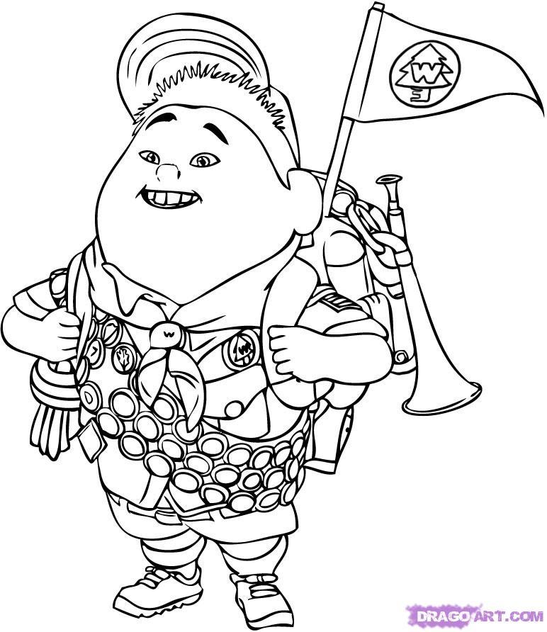
Booklet

¸

In the following project, you will write a moral story and create a photostory to illustrate it. You must include all the story elements seen in the deconstruction task and must have a photostory that last a minimum of 3 minutes. In order to do that you need to follow the steps below:
- Plan a story
- Write a draft
- Edit your work
- Write your final draft
- Create a story board
- Take your pictures
- Create your photostory

BOOKLET
- Individually, find a moral you learned through your life and would like to teach your classmates about.
  - On a separate sheet of paper, write the following information:
    - The moral
    - How you experienced/learned this moral

- As a team, do a round robin and share your morals. Decide which one you will use for the project.
  - Write the moral that you chose below.

Moral:____________________________________________________________________________________________________________________________________________________________________________________________

How did the person experience (learn) this moral? ____________________________________________________________________________________________________________________________________________________________________________________________________________________________________________________________________________________________________________________________________________________________________________________________________

- As a team, brainstorm ideas of titles and story elements that could teach your morale. You must base the story on a real life situation that one of the members experienced. However, you may add details if you wish so. Complete the form on the next page.

Complete this form to leave traces of step 3.
Brainstorming effectively
Each teammate must use a pen of a different color and sign their name with it on this sheet.
Name: Name:

Name: Name:

- Write an outline following the template. DON’T FORGET THAT YOU NEED TO TAKE PICTURES TO ILLUSTRATE YOUR STORY. IT NEEDS TO BE FEASIBLE.
Outline
Setting:

Characters:

Main events:

Conclusion:

- As a team, write your first draft. Use cooperative writing as previously seen in class.
_______________________________________________________________________________________________________________________________________________________________________________________________________________________________________________________________________________________________________________________________________________________________________________________________________________________________________________________________________________________________________________________________________________________________________________________________________________________________________________________________________________________________________________________________________________________________________________________________________________________________________________________________________________________________________________________________________________________________________________________________________________________________________________________________________________________________________________________________________________________________________________________________________________________________________________________________________________________________________________________________________________________________________________________________________________________________________________________________________________________________________________________________________________________________________________________________________________________________________________________________________________________________________________________________________________________________________________________________________________________________________________________________________________________________________________________________________________________________________________________________________________________________________________________________________________________________________________________________________________________________________________________________________________________________________________________________________________________________________________________________________________________________________________________________________________________________________________________________________________________________________________________________________________________________________________________________________________________________________________________________________________________________________________________________________________________________________________________________________________________________________________________________________________________________________________________________________________________________________________________________________________________________________________________________________________________________________________________________________________________________________________________________________________________________________________________________________________________________________________________________________________________________________________________________________________________________________________________________________________________________________________________________________________________________________________________________________________________________________________________________________________________________________________________________________________________________________________________________________________________________________________________________________________________________________________________________________________________________________________________________________________________________________________________________________________________________________________________________________________________________________________________________________________________________________________________________________________________________________________________________________________________________________________________________________________________________________________________________________________________________________________________________________________________________________________________________________________________________________________________________________________________________________________________________________________________________________________________________________________________________________________________________________________________________________________________________________________________________________________________________________________________________________________________________________________________________________________________________________________________________________________________________________________________________________________________________________________________________________________________________________________________________________________________________________________________________________________________________________________________________________________________________________________________________________________________________________________________________________________________________________________________________________________________________________________________________________________________________________________________________________________________________________________________________________________________________________________________________________________________________________________________________________________________________________________________________________________________________________________________________________________________________________________________________________________________________________________________________________________________________________________________________
- Edit your work.
  - Look up words in the dictionary for spelling.
Look up in your grammar for past tense and sentence structures.
Use your resources.
  - Team Peer Review.
Exchange your first draft with another team. Write comments on the other team’s draft and complete the peer review grid.
TEAM Peer Review
Criteria –  peer review | Questions | Suggestions for improvement/ comments/ questions
Read the moral story a first time…
Positive comment | - What do you like the best about this moral story?
Read the moral story a second time…
Content | - Please read the story carefully and underline everything you don’t understand.  - is the story related to the moral?  - are the characters presented?
FORM | - Can you find a moral?  __ yes __ no __ not sure  - Underline what you think is the moral of the story.  - Are markers (past tense) used to introduce the different actions? If so, put a BOX around them.
Other task requirement | - If you have any other constructive comments that could help the team improve their story, take the time to write them down.
Signature of all team members:

- Write your final draft.
Do not forget to integrate the comments you received from the team peer review.
______________________________________________________________________________________________________________________________________________________________________________________________________________________________________________________________________________________________________________________________________________________________________________________________________________________________________________________________________________________________________________________________________________________________________________________________________________________________________________________________________________________________________________________________________________________________________________________________________________________________________________________________________________________________________________________________________________________________________________________________________________________________________________________________________________________________________________________________________________________________________________________________________________________________________________________________________________________________________________________________________________________________________________________________________________________________________________________________________________________________________________________________________________________________________________________________________________________________________________________________________________________________________________________________________________________________________________________________________________________________________________________________________________________________________________________________________________________________________________________________________________________________________________________________________________________________________________________________________________________________________________________________________________________________________________________________________________________________________________________________________________________________________________________________________________________________________________________________________________________________________________________________________________________________________________________________________________________________________________________________________________________________________________________________________________________________________________________________________________________________________________________________________________________________________________________________________________________________________________________________________________________________________________________________________________________________________________________________________________________________________________________________________________________________________________________________________________________________________________________________________________________________________________________________________________________________________________________________________________________________________________________________________________________________________________________________________________________________________________________________________________________________________________________________________________________________________________________________________________________________________________________________________________________________________________________________________________________________________________________________________________________________________________________________________________________________________________________________________________________________________________________________________________________________________________________________________________________________________________________________________________________________________________________________________________________________________________________________________________________________________________________________________________________________________________________________________________________________________________________________________________________________________________________________________________________________________________________________________________________________________________________________________________________________________________________________________________________________________________________________________________________________________________________________________________________________________________________________________________________________________________________________________________________________________________________________________________________________________________________________________________________________________________________________________________________________________________________________________________________________________________________________________________________________________________________________________________________________________________________________________________________________________________________________________________________________________________________________________________________________________________________________________________________________________________________________________________________________________________________________________________________________________________________________________________________________________________________________________________________________________________________________________________________________________________________________________________________________________________________________________________________________________________________________________________________________________________________________________________________________________________________________________________________________________________________________________________________________________________________________________________________________________________________________________________________
- Using the story you wrote, create a storyboard. Illustrate your story here in order to know which pictures you will need to take.
Title
_____________________________ ______________________________ _____________________________ _____________________________
_____________________________ ______________________________ _____________________________ _____________________________
_____________________________ ______________________________ _____________________________ _____________________________
_____________________________ ______________________________ _____________________________ _____________________________
_____________________________ ______________________________ _____________________________ _____________________________
_____________________________ ______________________________ _____________________________ _____________________________
_____________________________ ______________________________ _____________________________ _____________________________
_____________________________ ______________________________ _____________________________ _____________________________
_____________________________ ______________________________ _____________________________ _____________________________
_____________________________ ______________________________ _____________________________ _____________________________
_____________________________ ______________________________ _____________________________ _____________________________
_____________________________ ______________________________ _____________________________ _____________________________
Credits
_____________________________ ______________________________ _____________________________ _____________________________
_____________________________ ______________________________ _____________________________ _____________________________
_____________________________ ______________________________ _____________________________ _____________________________
_____________________________ ______________________________ _____________________________ _____________________________

- Make a list of the prompts, costumes and other objects you will need in order to take your pictures. Decide where you will take the pictures.
- Separate the roles: who will be taking the pictures, who is playing which character, etc.
Use the template below to complete step 9 and 10
Students 1 | Role:  Prompts required:
Student 2 | Role:  Prompts required:
Student 3 | Role:  Prompts required:
Student 4 | Role:  Prompts required:

- Take the pictures
- Using Photo Story 3, create the photostory.
  - Upload the pictures.
  - Place the pictures in the order planned for your presentation.
  - Write text on pictures, as needed.
  - Record your text or dialog for each picture you took.

- Prepare your presentation.
  - Mention which moral you chose.
  - Explain why you chose this moral.
  - Analysis of your pictures.
Example: How did you show on your picture that your character was shy? (Nail baiting)
  - Separate the roles: who will present what?
Complete the table below to prepare for your presentation.
Student Name | Items to be presented
State which moral you chose:

Explain why you chose this moral:

 | Analysis of your pictures *:
 | Analysis of your pictures:
 | Presentation of the photostory
 | Introduction and conclusion of the presentation.
- Present your project to your classmates
* Since there is a lot to say, two students will present this section.

Self-Reflection
Oh yeah! | Not my Best. | Oups!  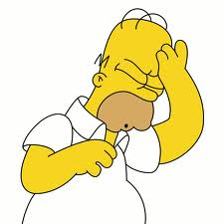
☐ | ☐ | ☐ | I spoke English with my peers.
☐ | ☐ | ☐ | I spoke English with my teacher.
☐ | ☐ | ☐ | I participated in the brainstorming process.
☐ | ☐ | ☐ | I participated in the writing of the first draft.
☐ | ☐ | ☐ | I used the dictionary.
☐ | ☐ | ☐ | I considered the feedback from our peers. (Attach the Peer Review form)
☐ | ☐ | ☐ | I participated in writing the final draft.
☐ | ☐ | ☐ | I contributed to the presentation of the photostory.

Are you good with everything?
Checklist for the photostory project
Check the items to make sure you do not miss a step.
Everything there should be handed in. You will lose points for missing items.
Done! | Oups!
☐ | ☐ | Brainstorming.
☐ | ☐ | Plot diagram.
☐ | ☐ | First draft.
☐ | ☐ | Proof of revision done before peer review.
☐ | ☐ | Filled in peer review grid, signed.
☐ | ☐ | Final draft. Edited version. It should show that you included feedback from your peers.
☐ | ☐ | Completed storyboard.
☐ | ☐ | Photostory 3 file. The final product.
☐ | ☐ | Preparation of the oral presentation table.
☐ | ☐ | Team self-evaluation form.
☐ | ☐ | Self-Reflective Sheet.

LES Schedule Plan
 | In class activity | Homework
Class 1 | Trigger activity  Task 1: Speaking activity | Go on the website moralstories.org and read 3 stories of your choice.
Class 2 | Task 2: Deconstruction  Task 3: Focus on form | Complete the simple past hand out.
Class 3 | Presentation of the project. Distribution of the booklet and formation of the teams (needs to be approved by the teacher).  Start task 4: Preparing to write. | Booklet p.1, step 1.
Class 4 | Finish task 4: Preparing to write.  If you have time, start task 5: writing the draft. | No homework, yeah!
Class 5 | Task 5: Writing the first draft.  Task 6: Revision
Class 6 | Task 7: Editing and writing the final draft
Class 7 | Task 8: Preproduction | Take the pictures and put them on a USB key
Class 8 | Task 8: Production of the photostory using Photo Story 3 | Finish your project if not done in class. Get ready for your presentation.
Class 9 | Task 8: Postproduction: Presentation of the project.

