School of Life

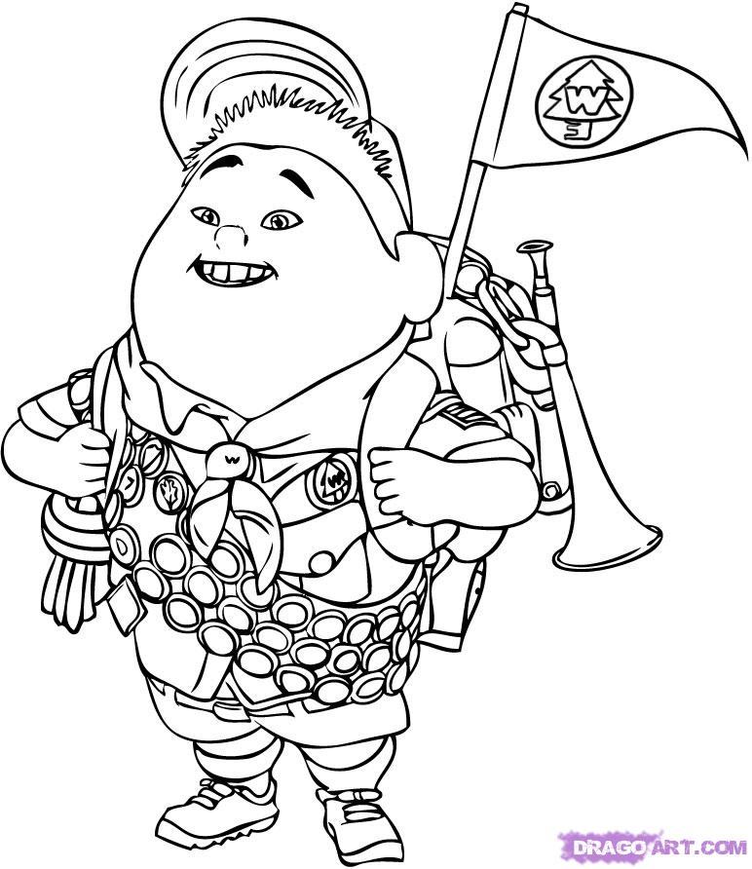

Created by
Carole-Anne Bonnafé
Geneviève Hardy
Junior Lessard
Ophélie Paré

Laval University
April 2013

CCreated by
Carole-Anne Bonnafé
Geneviève Hardy
Junior Lessard
Ophélie Paré
Laval University
April 2013

Created by
Carole-Anne Bonnafé
Geneviève Hardy
Junior Lessard
Ophélie Paré

Laval University
April 2013

HIGH SCHOOL CYCLE 1 YEAR 2
LES: SCHOOL OF LIFE

TRIGGER
C2
MORAL VIDEO

TASK 1
C1: SPEAKING ACTIVITY

KAGAN STRUCTURE

TASK 2
C2: DECONSTRUCTION OF A MORAL STORY
TASK 3
C3: FOCUS ON FORM

PAST TENSE

PRESENTATION OF THE PHOTOSTORY

DISTRIBUTION OF THE BOOKLET

BEGINNING OF THE PROJECT!

INTEGRATION

PHOTOSTORY

Preproduction

Production

Postproduction

TASK 7
C3: EDITING AND WRITING FINAL DRAFT

TASK 6
C3: REVISING
TASK 4
C3: PREPARING TO WRITE
TASK 5
C3: WRITING THE DRAFT

Broad areas of learning

health and well-being |  |  | environmental awareness and consumer rights and responsibilities
 |  | X
personal and career planning |  |  | citizenship and community life
 |  | X
media literacy

Focus of development of the BAL:

Personal development. Paying attention to experiences pay later because you know better how to react and to consider what happens to you.

Cross-curricular competencies

INTELLECTUAL | METHODOLOGICAL | PERSONAL AND SOCIAL | COMMUNICATION RELATED

To use information |  | To adopt effective work methods |  | To construct his/her identity |  | To communicate appropriately
 |  |  | X |  | X |  | X
To solve problems |  | To use information and communication technologies |  | To cooperate with others
 |  |  | X |  | X
To exercise critical judgment
 | X
To use creativity
 | X

ESL Competencies

INTERACTS  ORALLY IN ENGLISH | REINVESTS UNDERSTANDING  OF ORAL AND WRITTEN TEXTS | WRITES AND PRODUCES TEXTS

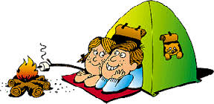  Initiates, reacts to, maintains and ends oral interaction |  | Listens to, reads and/or views texts |  | Uses a personalized writing process
 | X |  | X |  | X
Constructs meaning of the message |  | Constructs meaning of the text |  | Uses a personalized production process
 | X |  | X |  | X
Expands a personal language repertoire |  | Represents understanding of the text |  | Builds a personal inventory of writing and production resources
 | X |  | X |  | X

TRIGGER ACTIVITY

EXAMPLE OF A MORAL FROM A YOUTUBE VIDEO
Jonathan and Charlotte - Opera Duo @ Britain's Got Talent 2012 Auditions http://www.youtube.com/watch?v=0UoGMdf7lek&feature=player_embedded

ROLE OF THE STUDENTS
Participate. Watch the video. Reflect on the moral. Construct meaning of the text.
Understand the oral text presented in the video.

ROLE OF THE TEACHER
Ask some questions to introduce the video and the topic of the LES. Develop on the idea of “you can’t judge a book by its cover.”

MATERIAL :
Internet access, laptop, projector.

OTHER DETAILS :
Short trigger activity that would last approximately 10 minutes.
COMPETENCY 1
Initiates, reacts to, maintains and ends oral interaction

COMPETENCY 2
Listens to, reads and/or views texts

COMPETENCY 3



RELATED CONTENT |  |  |  | CCC | TRACES
CULTURE | PROCESS | STRATEGIES | TEXT TYPE AND FEATURES | - To exercise critical judgment.  - To use information and communication technologies. | No traces.  If ever needed, the teacher can take notes of students’ participation.
The aesthetic, sociological and sociolinguistic aspects of culture. | ☒ response process  ☐ writing process  ☐ production process | - Cognitive strategies | Video  Moral Story

TASK 1
C1: SPEAKING ACTIVITY

ROLE OF THE STUDENTS
Each student is responsible to discuss his or her story with the specialist group and then with the heterogeneous group.

ROLE OF THE TEACHER
Prepare eight moral cards.
Distribute one moral to each student.
Animate the speaking activity.
Make a wrap up and ask the students to come up with a definition of « moral. »
Remind the students to speak English.

MATERIAL
Moral cards: they will help the students to have ideas when discussing.
Functional language will be identified.

OTHER DETAILS
Concerning the response process, this task follows with the video in the trigger activity. This speaking activity consists of “establishing a personal connection with the text.” Also, the teacher should plan in advance the teams to minimize lost of time.
KAGAN STRUCTURE
Partner Expert Group Jigsaw

COMPETENCY 1
Initiates, reacts to, maintains and ends oral interaction
Constructs meaning of the message
Expands a personal language repertoire

COMPETENCY 2
Listens to, reads and/or views texts
Constructs meaning of the text

COMPETENCY 3



RELATED CONTENT |  |  |  |  | CCC | TRACES
CULTURE | PROCESS | LANGUAGE REPERTOIRE | STRATEGIES | TEXT TYPE AND FEATURES | - Exercises critical judgement  - Cooperates with others  - Communicates appropriately | Teacher takes notes of the students’ participation and oral abilities.
The sociological aspects of culture. | ☒ response process  ☐ writing process  ☐production process | - Functional language  - Other vocabulary | - Communication strategies  - Learning strategies | Morals

COMPETENCY 1
Initiates, reacts to, maintains and ends oral interaction
TASK 2

C2: DECONSTRUCTION OF A MORAL STORY

ROLE OF THE STUDENTS
Read the moral story.
Deconstruct the text. Find the features.
Students share their answers doing the heads together structure when the teacher asks to do so.

ROLE OF THE TEACHER
Have students notice the key parts of a moral story and also the time markers for past tense.
Remind the students to speak English.

MATERIAL
Handout of the moral story selected for the deconstruction task.
Handout of the deconstruction activity instructions.

OTHER DETAILS
Concerning the response process, this task is linked to the video presented in the trigger. This reading activity consists of “generalizing beyond the text.” It also is a context to start from to teach grammar.

COMPETENCY 2
Listens to, reads and/or views texts

COMPETENCY 3
Builds a personal inventory of writing and production resources

RELATED CONTENT |  |  |  |  | CCC | TRACES
CULTURE | PROCESS | LANGUAGE REPERTOIRE | STRATEGIES | TEXT TYPE AND FEATURES | - To adopt effective work methods  - Cooperates with others | The handout with the key features highlighted.  The deconstruction handout.
The aesthetic aspects of culture. | ☒ response process  ☐ writing process  ☐ production process | - Other vocabulary  - Focus on form  - Audience | - Learning strategies | Moral story  - Past tense

COMPETENCY 1



TASK 3

C3: FOCUS ON FORM - PAST TENSE

ROLE OF THE STUDENTS
Notice the features of Simple Past from the handouts distributed by the teacher. Ask questions.
Complete the activity about Simple Past verbs.

ROLE OF THE TEACHER
Conduct an activity about Simple Past.
Give some theory, answer questions, and give the opportunity for students to practice.
Make sure everyone understands.
Remind the students to speak English.

MATERIAL
Handouts.

OTHER DETAILS
Description of the task: The students review simple past by completing a simple past handout. On the handout there are present and past sentences. The students have to underline the time marker and fill in the blanks with the correct verb tense (present or past).

COMPETENCY 2
Listens to, reads and/or views texts
Constructs meaning of the text

COMPETENCY 3
Builds a personal inventory of writing and production resources

RELATED CONTENT |  |  |  | CCC | TRACES
CULTURE | LANGUAGE REPERTOIRE | STRATEGIES | TEXT TYPE AND FEATURES | - To adopt effective work methods  - To communicate appropriately | Simple past handout
The aesthetic, sociological and sociolinguistic aspects of culture. | - Focus on form | - Learning strategies | Moral story  - Past tense

PRESENTATION OF THE PHOTOSTORY
(The teacher explains that it is a model and that the final product should look like this one)

DISTRIBUTION OF THE BOOKLETS
(one per team)

BEGINNING OF THE PROJECT

ROLE OF THE STUDENTS
Watch the photostory presented by the teacher.
Listen carefully to the teacher when she or he presents the project.

ROLE OF THE TEACHER
Present the photostory model to the students explaining what the main features of the project are.
Introduce the booklet and make an overview of all the steps the students will have to go through. Remind the students to speak English.

MATERIAL
The students will be provided with a vocabulary list of words they probably don`t know and that they will need to know in order to understand the dialogue.

PRESENTATION AND BEGINNING OF THE PROJECT

COMPETENCY 1
Initiates, reacts to, maintains and ends oral interaction
TASK 4

C3: PREPARING TO WRITE

ROLE OF THE STUDENTS
Individually find a moral that they have learned during their life.
Share this moral with their team using the heads together structure and the functional language previously identified.
Select the moral they will use for their project.
Brainstorm on the story elements.
With their teammates, write the outline.
Cooperate and practice their oral skills.

ROLE OF THE TEACHER
Explain the work to the students.
Guide and help the students as needed.
Make sure all teams have the time to complete the work on time.
Remind the students of the importance of harmonious teamwork.
Remind the students to speak English.

MATERIAL
Booklet p.1,2,3

COMPETENCY 2



COMPETENCY 3
Uses a personalized writing process
Builds a personal inventory of writing and production resources

RELATED CONTENT |  |  |  |  | CCC | TRACES
CULTURE | PROCESS | LANGUAGE REPERTOIRE | STRATEGIES | TEXT TYPE AND FEATURES | - To adopt effective work methods  - To use creativity  - To cooperate with others  - To communicate appropriately | The brainstorming and the outline form, as well as page 1-3 of their booklet.
The sociolinguistic aspects of culture. | ☐ response process  ☒ writing process  ☐ production process | - Functional language | - Learning strategies  -Communication strategies | Moral story  - Past tense

COMPETENCY 1
Initiates, reacts to, maintains and ends oral interaction
TASK 5

C3: WRITING THE DRAFT

ROLE OF THE STUDENTS
Cooperatively write the draft: one student writes as the others give him ideas. Students should exchange the roles every now and then.
They interact and agree on the text choices.

ROLE OF THE TEACHER
Explain the task to the students and help them if they ask.
Foster the use of ressources.
Remind the students to speak English.

MATERIAL
Booklet p.4

OTHER DETAILS
Cooperative writing is not an easy task. The teacher might need to provide some extra guidance if the students have never worked this way.

COMPETENCY 2



COMPETENCY 3
Uses a personalized writing process
Builds a personal inventory of writing and production resources

RELATED CONTENT |  |  |  |  | CCC | TRACES
CULTURE | PROCESS | LANGUAGE REPERTOIRE | STRATEGIES | TEXT TYPE AND FEATURES | - To adopt effective work methods  - To use creativity  - To cooperate with others  - To communicate appropriately | The first draft must be handed in. It is part of the booklet (p.4). If extra sheets are used, they also must be handed in.
The sociolinguistic aspects of culture. | ☐ response process  ☒ writing process  ☐ production process | - Functional Language | - Learning strategies  - Communication strategies | Moral story  - Past tense

COMPETENCY 1
Initiates, reacts to, maintains and ends oral interaction
TASK 6

C3: REVISING

ROLE OF THE STUDENTS
Read the text.
Use resources to correct it.
Fill in the peer review table.

ROLE OF THE TEACHER
Remind the students of all the resources available.
Discuss the importance of being fair when completing the peer review.
Remind the students to speak English.

MATERIAL
Booklet p.5,6.

OTHER DETAILS
The teacher decides in advance who completes the peer review for each team.

COMPETENCY 2
Listens to, reads and/or views texts
Constructs meaning of the text

COMPETENCY 3
Uses a personalized production process
Present their project to their peers.

RELATED CONTENT |  |  |  |  | CCC | TRACES
CULTURE | PROCESS | LANGUAGE REPERTOIRE | STRATEGIES | TEXT TYPE AND FEATURES | - To adopt effective work methods  - To use creativity  - To cooperate with others  - To communicate appropriately | Booklet p. 5, 6.  The peer review table must be signed by all team members.
The sociolinguistic aspects of culture. | ☐ response process  ☒ writing process  ☐ production process | - Functional Language | -Learning strategies  - Communication strategies | Moral story  - Past tense

COMPETENCY 1
Initiates, reacts to, maintains and ends oral interaction
TASK 7

C3: EDITING AND WRITING FINAL DRAFT

ROLE OF THE STUDENTS
Integrate the comments from the peer review.
Write the final version of the text.
Work cooperatively.

ROLE OF THE TEACHER
Explain the task to the students and help them if they ask.
Circulate.
Remind the students to speak English.

MATERIAL
Booklet p. 9, 10, 11

COMPETENCY 2



COMPETENCY 3
Uses a personalized production process

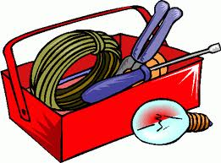

RELATED CONTENT |  |  |  |  | CCC | TRACES
CULTURE | PROCESS | LANGUAGE REPERTOIRE | STRATEGIES | TEXT TYPE AND FEATURES | - To adopt effective work methods  - To cooperate with others  - To communicate appropriately | Booklet p. 9, 10, 11
The sociolinguistic aspects of culture. | ☐ response process  ☒ writing process  ☐ production process | - Functional Language | -Learning strategies  - Communication strategies | Moral story  - Past tense

INTEGRATION
PHOTOSTORY
Preproduction

ROLE OF THE STUDENTS
Complete the storyboard. Dress a list of prompts and roles for the photostory.

ROLE OF THE TEACHER
Guide the students. Tell them that they should have fun and make their story alive and interesting.
Remind the students that they should remain realistic and take into account the constraints of their environment.
Remind the students to speak English.

MATERIAL
Booklet up to page 16.

COMPETENCY 1
Initiates, reacts to, maintains and ends oral interaction

COMPETENCY 2



COMPETENCY 3
Uses a personalized production process
Present their project to their peers.

RELATED CONTENT |  |  |  |  | CCC | TRACES
CULTURE | PROCESS | LANGUAGE REPERTOIRE | STRATEGIES | TEXT TYPE AND FEATURES | - To adopt effective work methods  - To use creativity  - To cooperate with others  - To communicate appropriately | Booklet up to page 16 needs to be completed.
The aesthetic, sociological and sociolinguistic aspects of culture. | ☐ response process  ☒ writing process  ☒ production process | - Functional Language | -Learning strategies  - Communication strategies | Moral story  - Past tense

COMPETENCY 1
Initiates, reacts to, maintains and ends oral interaction
INTEGRATION
PHOTOSTORY
Production

ROLE OF THE STUDENTS
Take the pictures.
Create the photostory using Photostory 3.
Bring all the necessary material to class.

ROLE OF THE TEACHER
Give time in class so the students do not have to meet outside of the class.
Remind the students to speak English.

MATERIAL
Reuse the storyboard. Booklet p.11.

OTHER DETAILS
Students might need to go outside of the class and bring material.

COMPETENCY 2



COMPETENCY 3
Uses a personalized production process
Present their project to their peers.

RELATED CONTENT |  |  |  |  | CCC | TRACES
CULTURE | PROCESS | LANGUAGE REPERTOIRE | STRATEGIES | TEXT TYPE AND FEATURES | - To use information and communication technologies  - To adopt effective work methods | Booklet p.11
The aesthetic, sociological and sociolinguistic aspects of culture. | ☐ response process  ☐ writing process  ☒ production process | - Functional Language | -Learning strategies  - Communication strategies | Moral story  - Past tense

INTEGRATION
PHOTOSTORY
Postproduction

ROLE OF THE STUDENTS
Complete the self-evaluation form.
Complete the checklist.
Hand in their work.
Prepare a clear presentation.
Present their project to their peers.

ROLE OF THE TEACHER
Correct the photo story.
Evaluate the whole process (booklet, LES, photostory).
Remind the students to speak English.

MATERIAL
Anything considered useful to present.

OTHER DETAILS

COMPETENCY 1
Initiates, reacts to, maintains and ends oral interaction

COMPETENCY 2



COMPETENCY 3
Uses a personalized production process
Present their project to their peers.

RELATED CONTENT |  |  |  |  | CCC | TRACES
CULTURE | PROCESS | LANGUAGE REPERTOIRE | STRATEGIES | TEXT TYPE AND FEATURES | - To use creativity  - To cooperate with others  - To communicate appropriately | No traces. The teacher should take notes during the presentation to evaluate the students.
The aesthetic, sociological and sociolinguistic aspects of culture. | ☐ response process  ☐ writing process  ☒production process | - Functional Language | -Learning strategies  - Communication strategies | Moral story  - Past tense

