Name_________________________

Temperature

Word Box
Cold | Hot | Frozen | Warm

How do you like your…?
Pool  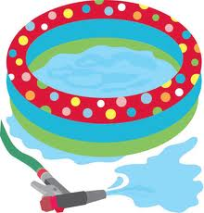  ___________________________ | Hot Chocolate  ___________________________
Ice Cream Cone  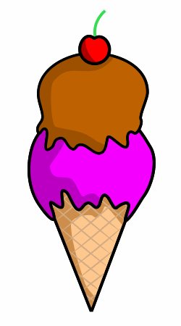  ___________________________ | Lemonade  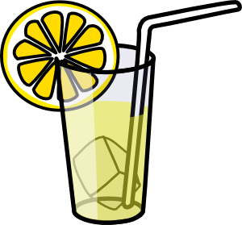  ___________________________

Give two examples of something hot.
_________________________ __________________________
Give two examples of something warm.
_________________________ __________________________
Give two examples of something cold.
_________________________ __________________________
Give two examples of something frozen.
_________________________ __________________________

Draw something COLD | Draw something HOT

