YOUR NYC MUST SEE!
C3 End of the Year Evaluation
Grade 5 students

You have until _____________________________ to surf the Internet and find your favorite attraction in New York. What is, according to you, a MUST SEE?

Below are two websites you can use. Others can do as well.
- http://www.time.com/time/travel/cityguide/article/0,31489,1843404,00.html
- http://www.smartdestinations.com/attractionList.ep?filters=_d_Nyc_Att&pass=exp

In class, you will have to write a text of minimum 70 words about the NYC attraction of your choice. To help you, you can bring to class all kinds of information. You can print interesting webpages and/or take notes on the back of this sheet as you browse NYC websites. It is forbidden to write your text at home, but you should fill out the mind map below.

Four information items need to be included in your text. It can be from the list below or not. Please check the items you choose to include and/or add the extra item(s) you wish to include. It is better to see what kind of information you can get before choosing.
- ☐ Price/fees (if any)
- ☐ Schedule (When it is opened and when it is closed.)
- ☐ Time (How long do you recommend to spend at this place?)
- ☐ Material (Do the visitors need to bring something?)
- ☐ Address
- ☐ History
- ☐ What you can see at this place.
- ☐ What you can do at this place.
- ☐ ________________________
- ☐ ________________________

The text should:
- ☐ be written in Simple Present.
- ☐ include at least one “MUST.”
- ☐ include at least one “CAN.”
- ☐ include at least one “SHOULD.”

You can use all your resources: dictionary, student book, agenda and so on. It is forbidden to copy the exact same sentences you find online. This is called plagiarism.

PREPARE TO WRITE (mind map to be done at home)
Write key information.
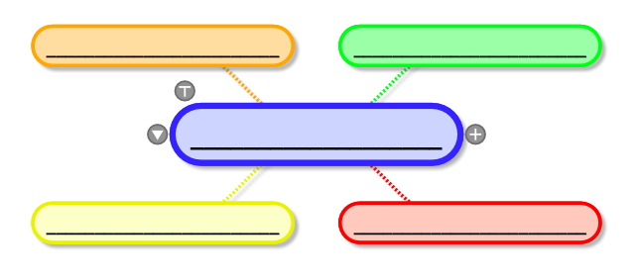

NOTE TAKING

FIRST DRAFT

*** Does your text include four information items?
***Use your dictionary and all your resources to correct your text!
***Check the evaluation rubric to make sure your text fits the requirements!

FINAL DRAFT

C3 Evaluation Rubric

 | A | B | C | D | E
Use of resources  (Writing Process) | The brainstorming contains several details. Student brought a lot of material to class. | The brainstorming contains enough details. Student brought all material to class. | The brainstorming contains some details. Student brought some material to class. | The brainstorming contains too few details. Student brought little material to class. | The brainstorming phase is not done. Student brought no material to class.
Compliance with instructions | All required items (4) are included and more. They make sense. | All required items are included. They make sense. | 1-2 required item(s) is(are) missing. Items do not always make sense. | 3 or more required items are missing. Items do not always make sense. | No required items included or the items do not make sense.
Language conventions targeted for task | The modals are perfectly used. | The modals are well used. 1-2 mistakes. | The modals are correctly used. 3-5 mistakes. | The modals are sometimes correctly used. 6-8 mistakes. | No modal used. 9+ mistakes
 | Plural nouns, capital “I” and simple present verbs are perfectly used. | Plural nouns, capital “I” and simple present verbs are correctly used. | Plural nouns, capital “I” and simple present verbs are sometimes correctly used. | Plural nouns, capital “I” and simple present verbs are rarely correctly used. | Plural nouns, capital “I” and simple present verbs are wrongly used.

